Autumn 1 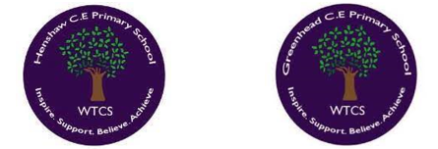
Year 5.6
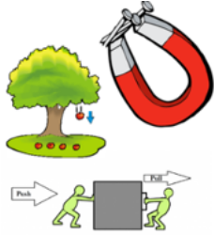
Forces
Year 5: Foundational Skills
- Gravity: I can explain that gravity is a force that pulls unsupported objects towards the Earth.
- Air, Water & Friction: I can identify and describe examples of air resistance, water resistance and friction in everyday life.
- Resistance: I can explain when it is useful to have high or low air resistance, water resistance or friction.
- Mechanisms: I can describe how simple mechanisms, including levers, pulleys and gears, help us to make work easier.
- Legacy: I know who Albert Einstein was and can describe an important contribution he made to science.

Golden Scientific Threads
- Enquiry – What scientific questions have we asked & answered?
- Observation – How have we observed science in practice?
- Evidence – What evidence have we researched or found out from our own experiments?

Autumn 1
Year 5.6
Forces
Year 6: Complex and Comparative Skills
- Gravity: I can explain and evaluate how gravity acts on objects and compare its effects with other forces.
- Air, Water & Friction: I can compare air resistance, water resistance and friction, explaining how each force affects the movement of an object.
- Resistance: I can analyse situations where increasing or reducing resistance is beneficial and justify my conclusions using scientific understanding.
- Mechanisms: I can explain how levers, pulleys and gears transfer forces and can evaluate how they make tasks easier or more efficient.
- Legacy: I can analyse Albert Einstein's scientific legacy and explain how his ideas changed our understanding of the world.

Golden Scientific Threads
- Enquiry – What scientific questions have we asked & answered?
- Observation – How have we observed science in practice?
- Evidence – What evidence have we researched or found out from our own experiments?

Autumn 2
Year 5.6
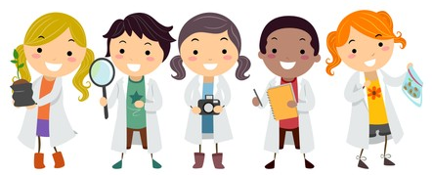
Working Scientifically
Year 5: Foundational Skills
Recording Data: I can record data and results using appropriate methods, including tables, keys, bar charts, line graphs and scatter graphs.
Presenting Findings: I can present my scientific findings in different ways, including displays, charts and presentations.
Conclusions: I can use my results to discuss conclusions and identify simple relationships or patterns.
Scientific Evidence: I can identify scientific evidence that supports an argument or conclusion.

Golden Scientific Threads
- Enquiry – What scientific questions have we asked & answered?
- Observation – How have we observed science in practice?
- Evidence – What evidence have we researched or found out from our own experiments?

Autumn 2
Year 5.6
Working Scientifically
Year 6: Complex and Comparative Skills
Recording Data: I can select and justify the most appropriate methods for recording and presenting complex scientific data.
Presenting Findings: I can communicate scientific findings clearly and effectively for different audiences using a range of appropriate formats.
Conclusions: I can analyse results to identify patterns, relationships and possible anomalies and use these to draw well-supported conclusions.
Scientific Evidence: I can critically evaluate scientific evidence and use reliable evidence to construct and justify a scientific argument.

Golden Scientific Threads
- Enquiry – What scientific questions have we asked & answered?
- Observation – How have we observed science in practice?
- Evidence – What evidence have we researched or found out from our own experiments?

Spring 1
Year 5.6
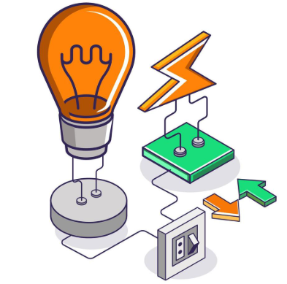
Electricity
Year 5: Foundational Skills
- Circuit Components: I can change cells and components in a circuit to achieve a specific effect.
- Circuit Diagrams: I can draw and interpret simple circuit diagrams using recognised scientific symbols.
- Voltage & Cells: I can investigate how changing the number or voltage of cells affects the brightness of bulbs or the volume of buzzers.
- Series Circuits: I can compare simple series circuits and describe differences in the brightness of bulbs, loudness of buzzers and operation of switches.
- Legacy: I know who Alessandro Volta was and can explain what he invented.

Golden Scientific Threads
- Enquiry – What scientific questions have we asked & answered?
- Observation – How have we observed science in practice?
- Evidence – What evidence have we researched or found out from our own experiments?

Spring 1
Year 5.6
Electricity
Year 6: Complex and Comparative Skills
Circuit Components: I can design, test and modify electrical circuits to achieve a specific purpose and explain how my changes affect the circuit.
Circuit Diagrams: I can accurately construct and interpret circuit diagrams using recognised symbols and use them to communicate complex circuit designs.
Voltage & Cells: I can analyse the relationship between the number and voltage of cells and the output of components in a circuit.
Series Circuits: I can compare and evaluate a range of series circuits, explaining the scientific reasons for variations in their performance.
Legacy: I can analyse Alessandro Volta's contribution to the development of electricity and explain its long-term impact on modern technology.

Golden Scientific Threads
- Enquiry – What scientific questions have we asked & answered?
- Observation – How have we observed science in practice?
- Evidence – What evidence have we researched or found out from our own experiments?

Spring 2
Year 5.6

Animals including humans
Year 5: Foundational Skills
Human Development: I can describe the changes that happen to humans from infancy to old age.
Circulatory System: I can draw and label a diagram of the human circulatory system, including the heart, blood vessels and blood.
Heart & Blood: I can describe the basic functions of the heart, blood vessels and blood.
Transport in the Body: I can explain how nutrients and water are transported around the bodies of animals and humans.
Legacy: I know who William Harvey was and can explain how his discovery improved our understanding of the human body.
Golden Scientific Threads
- Enquiry – What scientific questions have we asked & answered?
- Observation – How have we observed science in practice?
- Evidence – What evidence have we researched or found out from our own experiments?

Spring 2
Year 5.6
Animals including humans
Year 6: Complex and Comparative Skills
Human Development: I can explain and compare the physical and developmental changes humans experience throughout the different stages of life.
Circulatory System: I can explain how the parts of the circulatory system work together to transport essential substances around the body.
Heart & Blood: I can analyse the relationship between the heart, blood vessels and blood and explain how each contributes to keeping the body functioning.
Transport in the Body: I can explain how nutrients, water & essential substances are transported around the body and evaluate why this process is vital for survival.
Legacy: I can analyse the significance of William Harvey's discoveries and explain how they transformed medical understanding.
Golden Scientific Threads
- Enquiry – What scientific questions have we asked & answered?
- Observation – How have we observed science in practice?
- Evidence – What evidence have we researched or found out from our own experiments?

Summer 1
Year 5.6
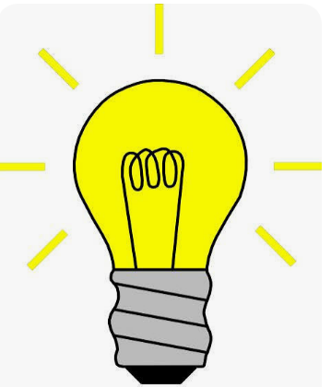
Light
Year 5: Foundational Skills
Light Travel: I can use diagrams to describe how light travels in straight lines and enters our eyes.
Shadows: I can explain how shadows are formed when light is blocked by an opaque object.
Reflection: I can describe how light can be reflected from mirrors and other reflective surfaces.
Changing Shadows: I can investigate and explain how changing the position of a light source or object changes the size and shape of a shadow.
Legacy: I know who Thomas Young was and can describe an important contribution he made to the study of light.
Golden Scientific Threads
- Enquiry – What scientific questions have we asked & answered?
- Observation – How have we observed science in practice?
- Evidence – What evidence have we researched or found out from our own experiments?

Summer 1
Year 5.6
Light
Year 6: Complex and Comparative Skills
Light Travel: I can explain, using scientific diagrams, how light travels in straight lines from a source, reflects from objects and enters the eye.
Shadows: I can analyse how the position, size and distance of a light source and object affect the size and shape of shadows.
Reflection: I can explain and compare how light behaves when it is reflected from different surfaces and use this understanding to predict the path of light.
Changing Shadows: I can plan and evaluate an investigation into the factors that affect shadows and use evidence to explain my conclusions.
Legacy: I can analyse Thomas Young's contribution to our understanding of light and explain the importance of his scientific legacy.

Golden Scientific Threads
- Enquiry – What scientific questions have we asked & answered?
- Observation – How have we observed science in practice?
- Evidence – What evidence have we researched or found out from our own experiments?

Summer 2
Year 5.6
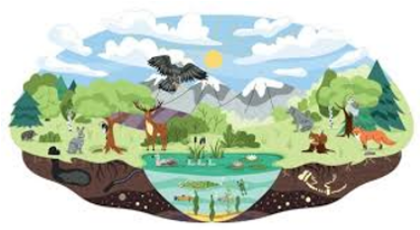
Living things and their habitats
Year 5: Foundational Skills
- Life Cycles: I can describe and compare the life cycles of a range of animals, including chickens, caterpillars, cows and frogs.
- Classification: I can classify animals using observable characteristics and explain the reasons for my choices.
- Animal Groups: I can identify examples of vertebrates and invertebrates.
- Characteristics: I can describe the key characteristics of vertebrates and invertebrates.
- Legacy: I know who Jane Goodall is and can explain what she discovered about chimpanzees.
Golden Scientific Threads
- Enquiry – What scientific questions have we asked & answered?
- Observation – How have we observed science in practice?
- Evidence – What evidence have we researched or found out from our own experiments?

Summer 2
Year 5.6
Living things and their habitats
Year 6: Complex and Comparative Skills
- Life Cycles: I can compare and analyse the life cycles of different animals, explaining similarities, differences and how these support survival.
- Classification: I can classify animals using increasingly detailed characteristics and justify my classification using scientific evidence.
- Animal Groups: I can compare different vertebrate and invertebrate groups and explain how their characteristics help scientists to classify them.
- Characteristics: I can analyse the structural characteristics of vertebrates and invertebrates and explain how these features relate to their movement, survival and habitats.
- Legacy: I can analyse Jane Goodall's discoveries about chimpanzees and explain how her research changed scientific understanding of animal behaviour.
Golden Scientific Threads
- Enquiry – What scientific questions have we asked & answered?
- Observation – How have we observed science in practice?
- Evidence – What evidence have we researched or found out from our own experiments?

