Autumn 1 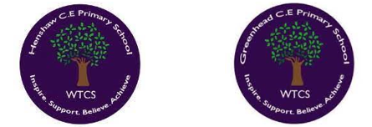
Year 5.6
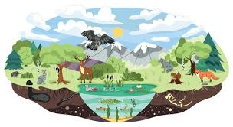
Living things and their Habitat
Year 6: Complex and Comparative Skills
- Plant Reproduction: I can explain the continuous plant life cycle in detail, tracing processes from pollination and fertilization through to seed dispersion.
- Reproduction Types: I can analyse the biological advantages and disadvantages of sexual versus asexual reproduction.
- Animal Growth: I can evaluate and contrast the reproductive processes and development cycles of various animal groups (including amphibians, birds, and mammals).
- Life Cycles: I can compare complex life-cycle changes across distinct living organisms and explain how these developmental adaptations aid survival.
- Legacy: I can explain exactly how David Attenborough’s contributions have revolutionized our modern understanding and study of the natural world.
Golden Scientific Threads
- Enquiry – What scientific questions have we asked & answered?
- Observation – How have we observed science in practice?
- Evidence – What evidence have we researched or found out from our own experiments?

Autumn 1
Year 5.6
Living things and their Habitat
Year 5: Foundational Skills
- Plant Reproduction: I can identify and describe the life processes of reproduction in plants, including key stages like seed, germination, seedling growth, flowering, and pollination.
- Reproduction Types: I can identify the differences between sexual and asexual reproduction in plants.
- Animal Growth: I can compare how different animals, such as a frog, chick, and human, reproduce and grow.
- Life Cycles: I can compare and describe basic life-cycle changes in a variety of living things, such as vegetables, animals, and flowers.
- Legacy: I know who David Attenborough is and can identify that his work changed the study of nature.
Golden Scientific Threads
- Enquiry – What scientific questions have we asked & answered?
- Observation – How have we observed science in practice?
- Evidence – What evidence have we researched or found out from our own experiments?

Autumn 2
Year 5.6
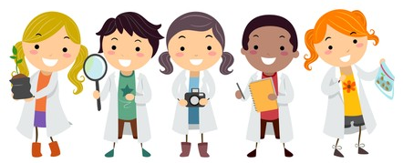
Working Scientifically
Year 5: Foundational Skills
- Enquiry Types: I can plan basic scientific enquiries (such as comparative testing or observation over time) to find answers to questions.
- Measuring & Equipment: I can decide what to measure in an experiment and take accurate measurements using basic equipment like measuring cylinders and thermometers.
- Investigating: I can recognize and identify when I might need to run further tests or make more observations.
- Secondary Sources: I can identify which secondary sources are useful to research my ideas.
- Legacy: I know who Isaac Newton was and can identify that he left behind a significant scientific legacy.

Golden Scientific Threads
- Enquiry – What scientific questions have we asked & answered?
- Observation – How have we observed science in practice?
- Evidence – What evidence have we researched or found out from our own experiments?

Autumn 2
Year 5.6
Working Scientifically
Year 6: Complex and Comparative Skills
- Enquiry Types: I can plan complex, multi-variable scientific investigations (such as fair testing and pattern seeking), ensuring I identify and control all variables.
- Measuring & Equipment: I can select and justify the use of specialized equipment (like funnels, measuring cylinders, and thermometers) to take highly precise and accurate measurements.
- Investigating: I can evaluate my experimental results to determine exactly when, why, and how further testing or observations are required.
- Secondary Sources: I can critically analyse secondary sources to evaluate their usefulness, actively separating scientific opinion from factual evidence.
- Legacy: I can evaluate the deep, long-term impact of Isaac Newton's discoveries on our understanding of physical forces and the modern world.

Golden Scientific Threads
- Enquiry – What scientific questions have we asked & answered?
- Observation – How have we observed science in practice?
- Evidence – What evidence have we researched or found out from our own experiments?

Spring 1
Year 5.6
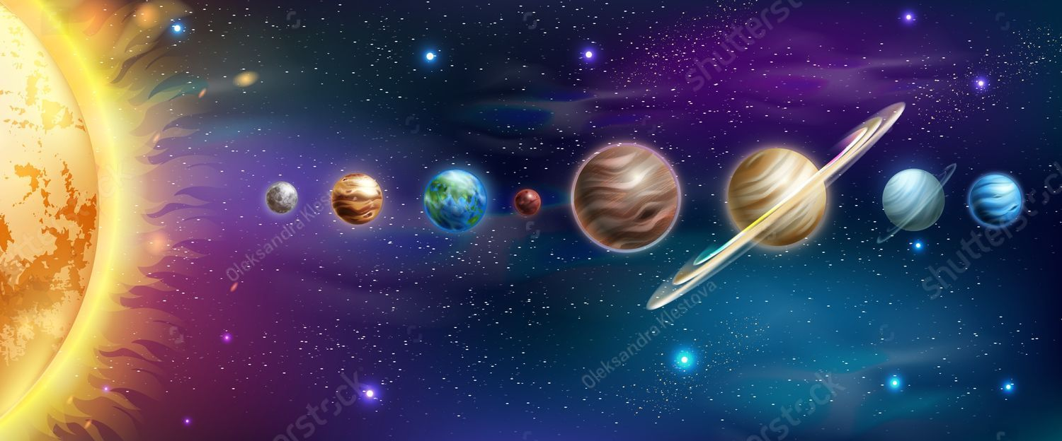
Earth and Space
Year 5: Foundational Skills
- Solar System: I can describe the structure of our Solar System using a labelled diagram and state a basic fact about each planet.
- Spherical Bodies: I can identify that the Sun, Earth, and Moon are spherical bodies and describe their basic movements.
- Moon Phases: I can describe and draw the different phases of the moon as it orbits the Earth.
- Night and Day: I can explain how night and day occur because the Earth rotates on its axis.
- Space Models: I can research scientist Ptolemy’s geocentric theory and understand that the Sun is the closest star to Earth.
- Legacy: I know who Michele Dougherty is and can identify that she made history in astronomy.
Golden Scientific Threads
- Enquiry – What scientific questions have we asked & answered?
- Observation – How have we observed science in practice?
- Evidence – What evidence have we researched or found out from our own experiments?

Spring 1
Year 5.6
Earth and Space
Year 6: Complex and Comparative Skills
- Solar System: I can analyse the layout of the Solar System, comparing the unique characteristics of different planets.
- Spherical Bodies: I can explain the physical principles of how spherical bodies like the Sun, Earth, and Moon interact and move in relation to one another.
- Moon Phases: I can explain the physical mechanics behind the changing phases of the moon as it completes its orbit around the Earth.
- Night and Day: I can explain how the Earth's continuous rotation causes day and night and analyse how this affects different parts of the world.
- Space Models: I can contrast Ptolemy’s geocentric theory with modern astronomical models, demonstrating why the Sun is classified as our closest star.
- Legacy: I can explain exactly how Michele Dougherty’s recent space exploration discoveries have made history and advanced the field of astronomy.
Golden Scientific Threads
- Enquiry – What scientific questions have we asked & answered?
- Observation – How have we observed science in practice?
- Evidence – What evidence have we researched or found out from our own experiments?

Spring 2
Year 5.6
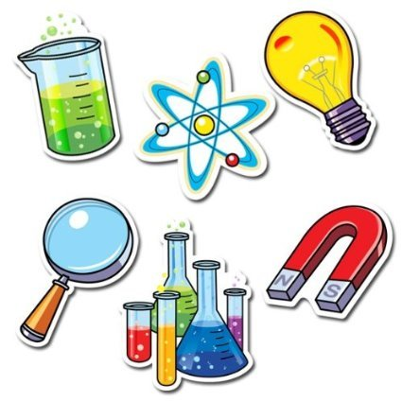
Properties and Changes of Materials
Year 5: Foundational Skills
- Properties & Grouping: I can compare and group different materials based on basic properties like hardness, solubility, transparency, and electrical/thermal conductivity.
- Material Uses: I can identify reasons why certain materials are used for specific items based on their properties.
- Solubility: I can identify at least three materials that dissolve in liquid and describe how we use dissolving in everyday life.
- Separating Mixtures: I can suggest basic ways to separate mixtures, such as filtering, sieving, or evaporating.
- Reversible Changes: I can demonstrate through simple tests that some changes (like dissolving and mixing) are reversible.
- Irreversible Changes: I can explain that some changes (like burning or the action of acid on bicarbonate) are irreversible - they form new materials.
- Legacy: I know who Claude Louis Berthollet was and what he discovered about material changes.
Golden Scientific Threads
- Enquiry – What scientific questions have we asked & answered?
- Observation – How have we observed science in practice?
- Evidence – What evidence have we researched or found out from our own experiments?

Spring 2
Year 5.6
Properties and Changes of Materials
Year 6: Complex and Comparative Skills
- Properties & Grouping: I can classify and compare materials based on complex physical and chemical properties (including solubility and conductivity).
- Material Uses: I can evaluate and justify the selection of materials for industrial or domestic uses based on their specific physical properties.
- Solubility: I can analyze the process of solubility, explaining what happens to dissolved substances and how this is applied to everyday processes.
- Separating Mixtures: I can design and execute a multi-step process to separate complex mixtures using techniques like filtering, sieving, and evaporating.
- Reversible Changes: I can evaluate through scientific experimentation the difference between reversible physical changes and reversible chemical changes.
- Irreversible Changes: I can explain the scientific mechanisms behind irreversible changes (such as the chemical reaction of acid on bicarbonate).
- Legacy: I can analyze how Claude Louis Berthollet’s findings on reversible and irreversible changes influenced modern chemistry.
Golden Scientific Threads
- Enquiry – What scientific questions have we asked & answered?
- Observation – How have we observed science in practice?
- Evidence – What evidence have we researched or found out from our own experiments?

Summer 1
Year 5.6
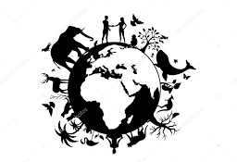
Animals (Including Humans)
Year 5: Foundational Skills
- Gestation: I can find out about and describe the gestation periods of different animals, such as the African Elephant, sheep, rabbit, and humans.
- Gestation Comparison: I can make simple comparisons between the gestation periods of different species.
- Healthy Living: I can describe basic ways to keep my body healthy, including diet, exercise, and lifestyle choices.
- Harmful Substances: I can identify at least three harmful substances (including drugs, alcohol, and expired food) and describe their general negative impacts on the human body.
- Legacy: I know who Sir Richard Doll and Austin Bradford Hill were and can identify what they discovered about smoking.

Golden Scientific Threads
- Enquiry – What scientific questions have we asked & answered?
- Observation – How have we observed science in practice?
- Evidence – What evidence have we researched or found out from our own experiments?

Summer 1
Year 5.6
Animals (Including Humans)
Year 6: Complex and Comparative Skills
- Gestation: I can explain why gestation periods vary so significantly across a range of mammals.
- Gestation Comparison: I can analyze and evaluate the correlation between an animal's physical traits or environment and its gestation period.
- Healthy Living: I can construct a detailed personal health plan, analysing long-term impact of diet, physical activity, and lifestyle choices on bodily systems.
- Harmful Substances: I can explain the specific biological damage and physiological effects that drugs, alcohol, and expired food have on the organs of the human body.
- Legacy: I can analyze the historical and medical significance of Sir Richard Doll and Austin Bradford Hill's research on smoking and public health.

Golden Scientific Threads
- Enquiry – What scientific questions have we asked & answered?
- Observation – How have we observed science in practice?
- Evidence – What evidence have we researched or found out from our own experiments?

Summer 2
Year 5.6
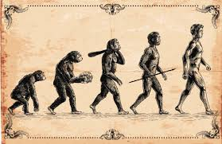
Evolution and Inheritance
Year 5: Foundational Skills
- Evolutionary Change: I can describe simple examples of how living things have changed over time.
- Fossils: I can describe how fossils (such as skeletons, teeth, and footprints) give us clues about animals that are no longer alive.
- Offspring: I know that animals reproduce to create offspring of the same kind, although they are not identical.
- Adaptation: I understand that animals and plants have features that help them adapt to survive in their environments, linking this to survival.
- Legacy: I know who Charles Darwin was and can describe his discoveries on the Galapagos Islands.

Golden Scientific Threads
- Enquiry – What scientific questions have we asked & answered?
- Observation – How have we observed science in practice?
- Evidence – What evidence have we researched or found out from our own experiments?

Summer 2
Year 5.6
Evolution and Inheritance
Year 6: Complex and Comparative Skills
- Evolutionary Change: I can evaluate fossil and physical evidence to explain how living things have evolved over millions of years.
- Fossils: I can analyse how diverse fossils (including footprints, teeth, and skeletons) provide deep evidence of ancient ecosystems and extinct species.
- Offspring: I can explain how inheritance works, showing that offspring share characteristics with their parents while also demonstrating variation.
- Adaptation: I can explain the scientific concept of 'survival of the fittest' and evaluate how specific adaptations allow species to survive in changing environments.
- Evolution Process: I can explain the process of evolution, detailing how species adapt slowly over extensive periods of time.
- Legacy: I can analyse the profound impact Charles Darwin's theories on the Galapagos Islands had on our scientific understanding of the natural world.
Golden Scientific Threads
- Enquiry – What scientific questions have we asked & answered?
- Observation – How have we observed science in practice?
- Evidence – What evidence have we researched or found out from our own experiments?

