Maths in Year 1
- Count to and across 100 from any number
- Count, read and write numbers to 100 in numerals
- Read and write mathematical symbols: +, - and =
- Identify "one more" and "one less"
- Use number bonds and subtraction facts within 20
- Add 1-digit and 2-digit numbers to 20, including zero
- Subtract 1-digit and 2-digit numbers to 20, including zero
- Recognise, find and name a half
- Recognise, find and name a quarter
- Measure and begin to record length, mass, volume and time
- Recognise and know the value of all coins and notes
- Use language to sequence events in chronological order
- Recognise and use language relating to dates
- Tell the time to the half-hour, including drawing clocks
- Recognise and name common 2-D shapes
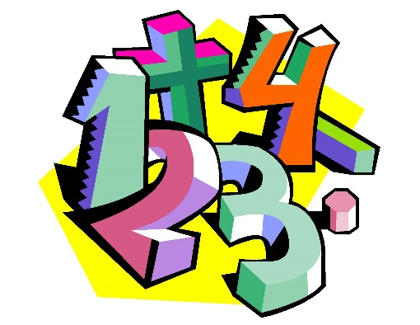
- Recognise and name common 3-D shapes

