Autumn 1 
Year 1.2
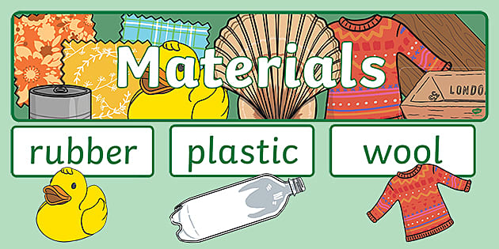
Everyday Materials Year 1 – foundational skills
I can name & identify everyday materials, including wood, plastic, metal, glass & paper.
• I can describe simple properties of materials, such as hard, soft, smooth, rough, bendy and waterproof.
• I can identify what material an object is, explaining why it’s suitable for use.
• I can group everyday materials according to their material or properties.
• I can identify different uses for everyday materials.
• I can describe how some materials can be changed by squashing, bending, stretching or twisting.
• I can carry out a simple test of different materials and record what I observe.
• I can explain who Robert Hooke was and describe his contribution to science.
Golden Scientific Threads
- Enquiry – What scientific questions have we asked & answered?
- Observation – How have we observed science in practice?
- Evidence – What evidence have we researched or found out from our own experiments?

Autumn 1
Year 1.2
Everyday Materials Year 2 – developing skills
• I can name and describe a range of everyday materials and their properties.
• I can group and classify materials in different ways according to their properties.
• I can explain why a particular material is suitable for a specific purpose.
• I can compare different materials used for the same object & explain which is most suitable.
• I can explain how the properties of a material affect how it can be used.
• I can describe how the shape of some solid objects can be changed by squashing, bending, stretching or twisting.
• I can investigate and compare materials, using my observations and results to answer a question.
I can explain who Robert Hooke was and describe his contribution to science.
Golden Scientific Threads
- Enquiry – What scientific questions have we asked & answered?
- Observation – How have we observed science in practice?
- Evidence – What evidence have we researched or found out from our own experiments?

Autumn 2
Year 1.2
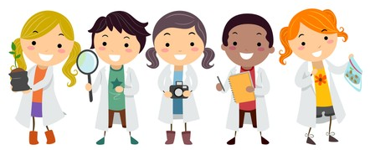
Working Scientifically Year 1 Foundational Knowledge
• I can ask simple questions about things I observe.
• I can suggest ways to find answers to simple questions.
• I can make observations using my senses and simple equipment.
• I can sort objects or living things into groups.
• I can carry out a simple test.
• I can use scientific vocabulary to talk about my observations and ideas.
• I can record my observations and collect simple information.
• I can say what I have found out from an investigation.
Golden Scientific Threads
- Enquiry – What scientific questions have we asked & answered?
- Observation – How have we observed science in practice?
- Evidence – What evidence have we researched or found out from our own experiments?

Autumn 2
Year 1.2
Working Scientifically Year 2 Developing Knowledge
• I can ask questions to be investigated scientifically & suggest ways to answer them.
• I can make careful observations using simple equipment.
• I can decide how to group objects or living things and explain my choices.
• I can carry out a simple test & make a prediction about what might happen.
• I can use scientific vocabulary to describe what I observe.
• I can gather and record data using tables, drawings, charts or simple diagrams.
• I can use my results to answer a scientific question & refer to my prediction.
• I can identify something I could change or improve in an investigation.
Golden Scientific Threads
- Enquiry – What scientific questions have we asked & answered?
- Observation – How have we observed science in practice?
- Evidence – What evidence have we researched or found out from our own experiments?

Spring 1
Year 1.2

Animals (Including humans) Year 1 Foundational Knowledge
• I can name & identify animals: fish, birds, amphibians, reptiles & mammals.
• I can give examples of animals from each animal group.
• I can identify animals as carnivores, herbivores or omnivores.
• I can identify and describe some of the basic body parts and features of animals.
• I can compare the structures and features of different animals.
• I can identify the basic needs of animals & humans, including food, water & shelter.
• I can explain why animals and humans need food and water to survive.
• I can explain who David Attenborough is and why he is important to the study of animals.
Golden Scientific Threads
- Enquiry – What scientific questions have we asked & answered?
- Observation – How have we observed science in practice?
- Evidence – What evidence have we researched or found out from our own experiments?

Spring 1
Year 1.2
Animals (Including humans) Year 2 Developing Knowledge
• I can classify animals into fish, amphibians, reptiles, birds and mammals and explain why they belong in each group.
• I can classify animals as carnivores, herbivores or omnivores and explain my choices.
• I can compare the body structures and features of different animals.
• I can describe how different animals are suited to their way of life.
• I can identify similarities and differences between humans and other animals.
• I can explain the needs of animals in order to survive: food, water, air & shelter.
• I can explain how animals depend on their habitats to meet their needs.
• I can explain who David Attenborough is and describe his contribution to understanding and protecting animals.
Golden Scientific Threads
- Enquiry – What scientific questions have we asked & answered?
- Observation – How have we observed science in practice?
- Evidence – What evidence have we researched or found out from our own experiments?

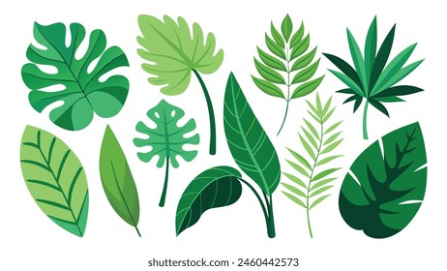
Spring 2
Year 1.2

Plants – Year 1 Foundational Knowledge
• I can name and identify common garden and wild plants.
• I can identify common deciduous and evergreen trees.
• I can identify common flowers such as daisies, dandelions, buttercups, carnations and daffodils.
• I can identify whether a plant grows from a seed or a bulb.
• I can describe what a seed or bulb needs to begin growing.
• I can describe the basic stages of a plant's growth.
• I can observe a plant as it grows and record changes I notice.
• I can explain who Jeanne Baret was and how she used plants to help others.

Golden Scientific Threads
- Enquiry – What scientific questions have we asked & answered?
- Observation – How have we observed science in practice?
- Evidence – What evidence have we researched or found out from our own experiments?

Spring 2
Year 1.2

Plants – Year 2 Developing Knowledge
• I can identify and name a range of common garden and wild plants and distinguish between deciduous and evergreen trees.
• I can identify the main parts of a plant, including roots, stem, leaves, flowers & fruit
• I can describe the function of the main parts of a plant.
• I can explain what plants need to grow and stay healthy.
• I can explain how plants grow from seeds/bulbs & describe stages of their life cycle.
• I can observe and record how plants change and grow over time.
• I can investigate what plants need to grow well and use my observations to compare different plants.
• I can explain who Jeanne Baret was &describe how plants were used in her work.
Golden Scientific Threads
- Enquiry – What scientific questions have we asked & answered?
- Observation – How have we observed science in practice?
- Evidence – What evidence have we researched or found out from our own experiments?

Summer
Year 1.2
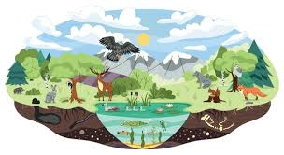
Habitats Year 1 Foundational Knowledge
• I can identify things that are living, dead and things that have never been alive.
• I can identify different habitats, such as forests, oceans and deserts.
• I can describe some features of different habitats.
• I can name plants and animals that live in a particular habitat.
• I can describe how a habitat provides what animals need to survive.
• I can explain why an animal is suited to its habitat.
• I can compare two different habitats.
• I can explain who Greta Thunberg is and why she wanted to protect forests.

Golden Scientific Threads
- Enquiry – What scientific questions have we asked & answered?
- Observation – How have we observed science in practice?
- Evidence – What evidence have we researched or found out from our own experiments?

Summer
Year 1.2
Habitats Year 2 Developing Knowledge
• I can explain the difference between living, dead & things that’ve never been alive
• I can identify a range of habitats, including microhabitats, & describe conditions.
• I can identify and describe plants and animals that live in different habitats.
• I can explain how a habitat provides plants & animals with what they need to survive.
• I can describe how plants and animals depend on each other within a habitat.
• I can compare different habitats and explain how they are similar and different.
• I can explain how changes to a habitat can affect the plants and animals living there.
• I can explain who Greta Thunberg is and why protecting habitats and the environment is important.
Golden Scientific Threads
- Enquiry – What scientific questions have we asked & answered?
- Observation – How have we observed science in practice?
- Evidence – What evidence have we researched or found out from our own experiments?

Year 1.2
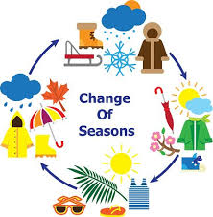
Seasonal Changes Year 1 Foundational Knowledge
• I can name and order the four seasons.
• I can describe the weather associated with each season.
• I can identify similarities and differences between the seasons.
• I can describe changes that happen to plants and animals during the seasons.
• I can describe how the length of the day changes during the year.
• I can identify changes that happen during each of the four seasons.
• I can observe and record the weather.
• I can explain what a meteorologist does.
Golden Scientific Threads
- Enquiry – What scientific questions have we asked & answered?
- Observation – How have we observed science in practice?
- Evidence – What evidence have we researched or found out from our own experiments?

Year 1.2
Seasonal Changes Year 1 Foundational Knowledge
• I can name and order the four seasons and describe typical weather patterns associated with each.
• I can compare the weather in different seasons & identify seasonal patterns.
• I can explain how the amount of daylight changes throughout the year.
• I can describe how plants and animals are affected by seasonal changes.
• I can explain how people adapt to changes in the weather and seasons.
• I can identify and describe changes that occur during each season.
• I can observe, record and use simple data to identify changes and patterns in the weather over time.
• I can explain the role of a meteorologist.

Golden Scientific Threads
- Enquiry – What scientific questions have we asked & answered?
- Observation – How have we observed science in practice?
- Evidence – What evidence have we researched or found out from our own experiments?

