English  We are continuing with our significant author – David Walliams and our class text for this half term is ‘The Demon Dentist’. Our guided reading text is ‘King of the Cloud Forests’ by Michael Morpurgo.  In writing, our focus will be diary writing, historical narrative, non-chronological report writing, explanation texts, newspaper reports and poetry. |  |  | R.E.  In R.E. this half-term, we will be finding out about Sikhism:  - The key beliefs in Sikhism – one God, the message of Guru Nanak, equality and service;  - Why service, human equality and dignity is important to Sikhs – The first Sikh scriptures;  - Why Guru Granth is important to Sikhs;  - What matters most in the Sikh community  - Some of the Sikh festivals will also be explored. |  | Maths  In maths, we will be consolidating our work on addition and subtraction using the formal column method. We will also be working on multiplication and division – with a focus on instant recall of multiplication facts in random order. We will use TT Rockstars and other resources to help support this.  We will also be looking at length and perimeter using a range of different measures – millimetres, centimetres, metres and kilometres. |  | PSHCE/RSE  In PSHCE/RSE, we will be thinking about our ‘Goals, Dreams and Aspirations – with a particular focus on self-care, support and safety – creating a physically and mentally healthy long-term goal for ourselves. Within this, we will be thinking about our feelings; positive affirmations, managing big feelings; zones of regulation; resilience; reframing negative thoughts into positive thoughts and loss and bereavement.
The Danube  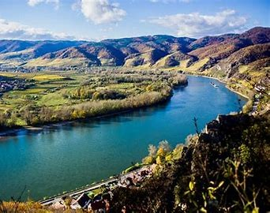  Curriculum Grid  Spring 1  Y3/4 |  | Science  In science, we will be finding out about light:  - Recognise that we need light in order to see things;  - That dark is the absence of light;  - Notice that light is reflected from surfaces;  - That light from the sun can be dangerous and that there are ways to protect our eyes from the sun;  - Recognise that shadows are formed when the light from a light source is blocked by a solid object and,  - to find patterns in the way that the size of shadows change.  The children will continue to apply their knowledge of working scientifically from last term. |  | Geography  In Geography, we will be finding out about:  In the Misty Mountain, Winding River project, your child will learn about the characteristics and physical processes of rivers, including how they shape the landscape over time, their significance around the world and the impact of flooding. They will learn how to use the eight points of a compass, four and six-figure grid references, symbols and a key to locate and plot geographical places and features on a map, as well as how contour lines are used to show the topography of an area. They will have the opportunity to learn about the stages of the water cycle and about mountains and their different formations, studying mountain ranges in the United Kingdom and around the world. They will also learn about habitats and how human and natural influences can have an impact on the environment.  The children will learn about Rivers; Maps; Grid references; Contour lines; Physical processes – erosion, transportation and deposition; World rivers; Aerial images; Mountains; UK mountains; World mountains; Compass points; Water cycle; Soil; Altitudinal zones; Data analysis. |  |  |  | P.E.  In P.E. this half-term, we will be focusing on dance. In NUFC sessions, we will be looking at striking and fielding.  Children will need to come in their P.E. kits on Tuesday and Thursday each week.  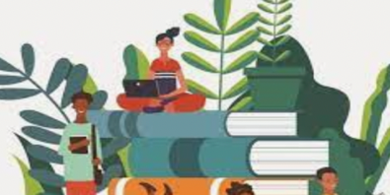  Year 3 children will also need appropriate outdoor learning clothing for a Thursday morning.
French  In French, we will be recognising and recalling 7 modes of transport. We will recall numbers and colours. We will work on phonics and pronunciation on – avion, camion; ou in roule and double and oi as in voiture. We will also continue to reinforce our learning so far. | Music  In music, we will be following our Charanga theme – our focus will be ‘The Dragon Song’. In this module, we will be listening to folk melodies from around the world including:  - Birdsong – Chinese folk music;  - Vaishnava Java – A Hindu song;  - A Turkish traditional tune;  - Aitutaki Drum Dance from Polynesia, and  - Zebaidir song from Sudan.  We will be listening and appraising, using glockenspiels, singing in 2 parts and performing and sharing our work. |  |  |  |  | Computing  In computing, we will be working on ‘Sequencing Sounds’. We will explore the concept of sequencing in programming through ‘Scratch’. We will be introduced to a selection of motion, sound, and event blocks which we will use to create our own programs, featuring sequences. The final project is to make a representation of a piano. The unit is paced to focus on all aspects of sequences, and make sure that knowledge is built in a structured manner. |  |  | 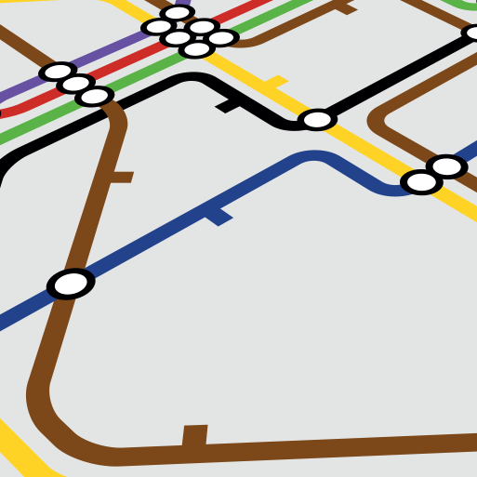

Links to our curriculum drivers Danube Class Spring 1 Y3/4
The following drivers underpin our school curriculum and, with our vision and values, allow us to deliver our curriculum strategy. These key drivers are personal to our schools and reflect the locational, social and educational needs of our community.
Curriculum Driver | Links within our curriculum this half term
Christianity and Faith | - R.E. Learning about Sikhism, it’s culture and beliefs  - PSHCE – Goals, Dreams and Aspirations – supporting our mental health, physical safety and the ‘right’ to have our own beliefs.  - Listening to and engaging with our R.E. Leaders
Our Local Area | - Geography which explores our local area – transport networks  - Workshop with Northumbria water  - Joint project with Henshaw primary school about mining and our local community.
Outdoor Growing, Learning and Environment | - Eco Schools Representatives making our school more eco-friendly  - Outdoor learning and gardening  - Year 3 and Reception class forest school sessions
Wider World and Diversity | - Listening to and engaging with our School Council  - French – Learning about a different language and culture  - Music from other cultures – around the World  - Geography – studying different cultures around the World  - Computing – Programming – Sequencing Sound  - R.E. Learning about Sikhism, it’s culture and beliefs  - Guided Reading – The geography of China and Tibet

