PSED  In PSED this half term we will be getting to know one another and will be establishing positive friendships and relationships. We will be settling into the new rules and routines of school.  We will be learning to get along together – playing cooperatively and taking turns. We will use ‘The Colour Monster’ stories to explore our own needs and feelings.  We will practise being helpful, kind and thoughtful.  We will learn how we are unique and special through the ‘Elmer’ stories.  We will be taking part in Commando Joe sessions to support our team work, resilience and problem solving skills. |  |  | R.E.  In R.E. this half-term, we will be learning why God is important to Christians. We will learn how Christians believe that God created the world. We will explore The Creation bible story. We will think about how we need to look after our world. We will learn about and celebrate Harvest. | Physical Development  In P.E. this half-term, we will be focusing on Speed, Agility and Travel.  We will enjoy a range of PD activities including Dough disco, Squiggle while you Wiggle and Penpals handwriting activities. We will use meditation and yoga throughout the week to further strengthen our bodies and learn how to relax.  Children will need to come in their P.E. kits on Tuesday and Thursday each week.
Eden Class  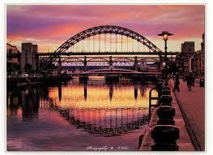  Curriculum Grid  Autumn 1 | Literacy  This half term we will be exploring our class texts including The Little Red Hen and Once There were Giants. We will be paying attention and responding to the pictures and the words and will be repeating words and phrases.  We will be developing phonological awareness so we can: spot rhymes, count or clap syllables, recognise words with the same initial sound.  We will be learning to recognise and write our names and other familiar words and will understand print has meaning.  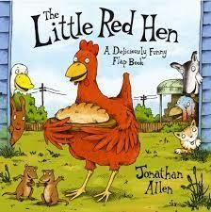  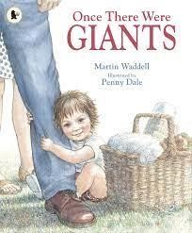  In phonics we will be starting to learn and develop our knowledge and understanding of everyday sounds and letters, sounds and words through our Read Write Inc programme. |  |  |  | Understanding the World  This half term we will be learning about our own beliefs, traditions, e.g. birthdays and other important aspects of our lives and those of others. We will be talking about members of our family and community. We will draw our families and create dream homes.  We will explore the natural world around us during Forest School. We will watch how seasons change and will learn about Autumn. We will go on an Autumn walk and pick berries. We will make crumble and bread.
Expressive Art and Design  This half-term we will begin to use different tools and materials to express our ideas through art construction and, modelling.  We will explore, use and refine a variety of artistic effects such as collage to create our dream homes. We will paint self-portraits paying attention to the colour and shape of our features We will join in with role-play and storytelling and will develop storylines in our pretend play.  In Music we will be exploring growing, homes, colour, toys and how I look. We will learn songs such as ‘Name Song’ and ‘Things For Fingers’. We will explore pulse, rhythm and pitch, voices and classroom instruments. |  | Maths  In maths this half term we will start our maths mastery journey through maths talk, practicing the skills we've learned during play and developing number sense.  We will be:  - Using our visual timetable to understand key times of the day and class routines.  - Exploring our classroom provision (inside and outside). Learning where things belong and using positional language.  - Joining in with our daily calendar, learning the days of the week.  *Singing number songs and rhymes and playing number games.  *Matching, sorting and comparing amounts.  - Counting, representing, comparing and understanding the composition of numbers 1, 2, 3, 4, 5.  - Learning about familiar 2D shapes and colours.  *Exploring and making patterns.  *Comparing size, mass and capacity.

Links to our curriculum drivers Eden Class Autumn 1 Reception
The following drivers underpin our school curriculum and, with our vision and values, allow us to deliver our curriculum strategy. These key drivers are personal to our schools and reflect the locational, social and educational needs of our community.
Curriculum Driver |  | Links within our curriculum this half term
Christianity and Faith | • | R.E. - The story of The Creation
 | • | What is Christianity? Why is God important to Christians?
 | • | Our own beliefs
 | • | PSED - Celebrating our differences
 | • | Harvest Celebration in our local church
Our Local Area | • | Harvest in our community - farming
 | • | Understanding of the World – Our families and local communities
Outdoor Growing, Learning and Environment | • | Forest School – exploring our local environment
 | • | Autumn walk – berry picking and crumble making
 | • | Maths in nature
 | • | Science – how yeast works
 | • | Bread making
 | • | Harvesting vegetables from our school garden
Wider World and Diversity | • | PSED - being me – diversity (being different) Elmer stories
 | • | School Council
 | • | Computing – online safety

