Marking and Feedback Policy

Written by: | The staff of Henshaw and Greenhead Primary Schools
Reviewed by Governors | 6th February 2024
Signed: M Glenton Date: September 2022
Date Reviewed by Governing Body: September 2022 Reviewed by staff: September 2022
Next Review Date: Autumn 2024
Introduction
“Feedback is one of the most powerful influences on learning and achievement”
Hattie and Timperley, 2007

At Greenhead and Henshaw Schools, we recognise the importance of feedback as part of the teaching and learning cycle, and aim to maximise the effectiveness of its use. However, we are also mindful of the workload implications of written marking, and of the research surrounding effective feedback.
Our policy is underpinned by evidence of best practice from the Education Endowment Foundation whose research shows that effective feedback should:
- Redirect or refocus either the teacher’s or the learner’s actions to achieve a goal
- Be specific accurate and clear
- Encourage and support further effort
- Be given sparingly so that it is meaningful
- Provide specific guidance on how to improve and not just tell students when they are wrong
As the Department for Education’s research into teacher workload has highlighted written marking as a key contributing factor, we aim to find alternatives to onerous written marking which provide effective feedback in line with the EEF’s recommendations, and those of the DfE’s expert group which emphasises that marking should be: meaningful, manageable and motivating.
We have also taken the advice provided by the NCETM (National Centre for Excellence in Teaching Mathematics) that the most important activity for teachers is the teaching itself, supported by the design and preparation of lessons.

Key Principles
Our policy on feedback has at its core a number of principles to ensure that it is both manageable and sustainable:
- the sole focus of feedback and marking should be to further children’s learning;
- evidence of feedback and marking is incidental to the process; we do not provide additional evidence for external verification;
- written comments should only be used where they are accessible to students according to age and ability;
- feedback is part of assessment processes in the classroom, and takes many forms other than written comments;
- feedback is a part of the school’s wider assessment processes which aim to provide and appropriate level of challenge to pupils in lessons, allowing them to make good progress;
- all pupils’ work should be reviewed by teachers at the earliest appropriate opportunity so that it impacts on future learning. When work is reviewed, it should be acknowledged in books.
We believe that pupil’s self-esteem and resilience will develop through positive yet challenging feedback. As a result, this will accelerate progress. For this reason, all marking and feedback is underpinned by this policy, which all pupils and staff follow on a day to day basis.
Feedback and Marking in Practice
It is vital that teachers evaluate the work that children undertake in lessons and use the information obtained from this to adjust their teaching. Based on the work of the Assessment Commission, feedback will be given in three ways and aims to give teachers the ability to use the most effective forms of feedback:
- Immediate feedback – at the point of teaching, possibly 1:1 or in small groups
- Summary feedback – at the end of a lesson/task, possibly through a plenary
- Review feedback – away from the point of teaching (including written comments)
The stages are deliberately numbered in order of priority, noting that feedback closest to the point of teaching and learning is likely to be most effective in driving further improvement and learning.

At Greenhead and Henshaw Schools this can be seen in the following practices:
Type | What it looks like | Evidence (for observers)
Immediate | - Includes teacher gathering and providing feedback from teaching (whiteboards, book work etc)  - Takes place in lessons with individuals or small groups  - Often given verbally to pupils for immediate action  - Given by CT and TA to provide support or further challenge  - May re-direct the focus of teaching or the task  - May change the direction or teaching within the lesson.  - Through effective questioning , mini-plenaries  - Include highlighting/annotations according to the marking code during the lesson | - Lesson observations/ learning walks  - Some evidence of annotations or use of marking code/ highlighting during work scrutiny  - Pupil voice illustrates children understand and can verbalise how and when marking is made.
Summary | - Often takes place at the end of a lesson or activity  - Often involves whole groups or classes  - Provides an opportunity for evaluation of learning in the lesson  - May take the form of self or peer-assessment against an agreed set of criteria  - May guide a teacher’s further use of review feedback, focusing on areas of need | - Lesson observations/learning walks  - Evidence of self and peer-assessment  - May be reflected in selected focus review feedback (marking)
Review | - Takes place away from the point of teaching  - May involve written comments/ annotations for pupils to read/ respond to  - Provides teachers with opportunities for assessment of understanding  - Leads to adaptation of future lessons through planning, grouping or adaptation of tasks  - May lead to targets being set for pupils’ future attention or immediate action  - May result in Target and Assessment Grids and I can statements being highlighted or assessed as complete. | - Acknowledgement of work completed  - Written comments and appropriate responses/actions taken  - Adaptation to teaching sequences  - Use of annotations

Light touch/acknowledgment marking
All work will be acknowledged in some form by class teachers or teaching assistants. This may be through simple symbols such as ticks, stickers, stamps, merits or by highlighting the learning intention/enquiry question. Where a child has achieved the intended outcome and is well-prepared for the next stage in learning, this will be acknowledged.

Developmental/Quality Marking
In most cases, written comments will be focused on extended pieces of written work, or extended tasks. These will allow children’s achievements to be recognised and provide further guidance for future learning. Examples of this guidance could be:
- Reminder – most suitable for high achievers. What else could you say about … Explain your thinking about …. Add more detail to ….
- Scaffold – most suitable for children needing a little more support – provide examples of what they need to do. Ask questions or provide unfinished sentences.
- Example prompt – suitable for all, especially lower abilities. Give children a choice of words or phrases e.g. choose one of these words instead of bad …
- Modelled Example – a correct example modelled by a teacher/teaching assistant with a further one for the child to try.
- Open Question – pose an open question specifically related to the LO to think about next steps.
- Greater Depth/Explanation – use to extend a child’s learning by asking them to explain their learning or reflect on the process or strategies they have used.
Stages of giving feedback
- Showing success (highlight in green - green is great, so children can see their successes clearly).
- Indicating improvement/next steps. The class teacher marks in red pen and HLTAs/TAs then children respond in pink – pink to think. This will happen in all longer written pieces, two Maths pieces of work a week and in Science and RE. Staff have agreed that think pink will be alternate between year groups in the class for Maths, Science and RE to ensure focus, guidance and appropriate time can be spent on next steps. Think pink comments will always be used for longer, written pieces.
- A black pen is used for all children to write in from Year 4 to Year 6. Children receive their pen licence in Year 3 once criteria is met.
- A page post it is placed after the teacher comment to highlight to children where the pink to think work is required.
- The child then responds to the teacher comment.
- The page post it is kept on the piece of work until the teacher collects the books at the end of the lesson.
- The teacher then reassess (with a tick) the pink to think to make sure it is complete and then removes the page post it.
* Foundation subjects will be marked with a tick and think pink criteria will be used if the teacher believes it is needed (Not including Science and RE where alternate year groups receive think pink comments). 1-2 spelling errors will be addressed in foundation pieces of work and the children will respond to these by copying these words out three times at the start of the next lesson. Teachers/TAs should circulate during the start of the lesson to ensure words are being spelt correctly. These spellings should be marked with a simple tick and checked at the next point of marking/assessment.

It isn’t feasible to expect teachers to give all pupils verbal feedback during every lesson, so self-assessment, peer assessment or teacher developmental/quality marking can occur.
It is essential that time is given for children to respond to prompts, thus enabling them to ‘close the gap’ and improve their work. Dedicated time for making improvements needs to be planned. Children should use pink pens and are expected to edit and improve their work or answer questions.
Teachers and teaching assistants should check that the improvement has been done through a simple tick. If misconceptions have occurred again, these will need to be addressed.
Specific examples - Maths
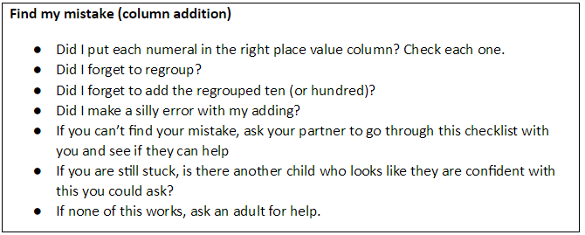
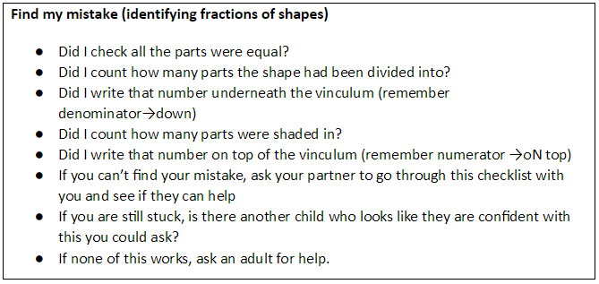

Specific examples - English
In-depth marking will take place after the final independent writing piece using the marking code (See Appendices) to address basic skills, grammar objectives and the relevant year TAGs. These pieces should be given more detailed written feedback.
If a high frequency word is misspelt, the teacher should identify this (up to 3 examples) and record the correct spelling at the end of a piece of work. Children should then write this spelling out three times. The teacher/TA MUST recheck this after the child has completed this to ensure these words are now spelt correctly.

Children as Markers (Self and Peer Assessment)
Self and peer assessment have a key role to play in effective marking and feedback – they empower children to take control of their own learning. Teachers should employ these regularly within the teaching week.

Self-Assessment
All our Learning Objectives are written as a question that children should be able to self-assess their work to ascertain whether they have achieved the focus of that lesson. Before any child (in Key Stage 1 and Key Stage 2) hands in any piece of work for marking they should spend an appropriate amount of time checking they re-read their work and made improvements. This time will be planned in as part of the self-assessment time either before the end of the lesson or as a focus of the next lesson, whichever is most appropriate for the task.

Marking codes
Where written marking or annotations are appropriate, the intention is that minimum teacher time should lead to maximum outcomes. Teachers should complete a success criteria grid for extended written lessons, RE and Science (See appendix). Marking codes, the use of I can statements and TAGs, have been developed for consistent use across the school to make feedback accessible for children and to make marking and feedback manageable for teachers although some additional age-appropriate elements may be included in some phases of the school, such as in Early Years.
Marking codes should be displayed in class and shared with children.
Policy Monitoring, Review and Evaluation
Marking and feedback will be closely monitored by subject leaders and SLT through:
- Lesson observations/learning walks
- Book scrutiny
- Pupil discussion
- Moderation
Appendix: Written marking codes
- To be used in Key Stage 1 by specific place (ringing the mistake)
- To be used in Key Stage 2 within the margin. Year 2 will transition to this in the Summer Term.
The coding must be available to children and staff in the classroom to check regularly. Review marking should be completed neatly in red pen using the agreed school script.
Margin  Symbol | Meaning
P | Correct punctuation (sometimes accompanied by clue eg . ! ? ‘ , : ; “ )
CL | Capital Letter needed
G | Correct the grammar
SP. | Correct the spelling (placed at the end of the piece of work, bottom of the page)
V | Improve the vocabulary
 | Add in the omitted word
/ | Finger space is required
\\ NP | Insert to show where a new paragraph should have been
c | Correction is needed (specifically used in Maths). This is to be revisited and marked by the adult when visited during next marking session.
green highlighted bar | Impressive punctuation, vocabulary, conjunction, genre specific example.  Highlighted I can statements (Foundation subjects)
E | Identifies section that does not make sense or needs editing and improving (should be re-written at the end of the piece of work, bottom of the page).

Success Criteria – used in Writing, RE, History, Geography and Science
Link to NC (and tracker if applicable) | 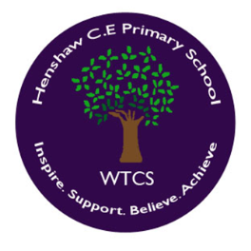  Supported work  Independent work  Verbal feedback given
Success Criteria | Self | Teacher

