English  Our class texts are books by Roald Dahl – our significant author. We are starting with ‘The Twits’.  Our guided reading text is: ‘Stig of the Dump’ by Clive King. We are also looking at the poet Benjamin Zephaniah and his work – ‘People will always need people’.  Our writing styles for this half-term are:  Diary, issues and dilemma narrative, newspaper report, explanation. In poetry, we will be learning about cinquains and riddles. | R.E.  In R.E. this half-term, we will be finding out about creation and fall. By the end of this unit, we will be able to place the concepts of God and Creation on a timeline of the Bible’s ‘Big Story’. We will make clear links between Genesis 1 and what Christians believe about God and Creation. We will describe what Christians do because they believe God is Creator. (For example, follow God, wonder at how amazing God’s creation is; care for the earth in some specific ways.) We will ask questions and suggest answers about what might be important in the creation story for Christians living today, and for people who are not Christians. |  |  | Maths  In Maths, during this half-term, our objectives will focus on place value and addition and subtraction:  We will be learning to:  Year 3: To understand the value of numbers up to 3 digits and be able to partition them; apply number bonds to 10; add and subtract numbers to 3 digits.  Year 4: To be able to represent numbers to 1000; add and subtract numbers to 4 digits, estimate, check by completing the inverse operation. | History  In history, we are following a theme called ‘Through the Ages’. We will be finding out about life in the Stone Age, Iron Age and Bronze Age. We will have learnt some historical vocabulary. We will also have begun to understand chronology and timelines. Whilst studying these civilisations, we will be looking at their everyday life; the tools and weapons they used; their settlements; the stonework and metalwork they created; their religion and beliefs; wealth and power; their inventions and ingenuity. We will use evidence available to us and develop our enquiry skills. |  |  | PSHCE/RSE  This is all about ‘Being Me’. We will be learning how friendships support wellbeing and the importance of seeking support if feeling lonely or excluded. We will know how to recognise if others are feeling lonely and excluded and have learnt some strategies to include them. We will learn how to build good friendships, including identifying qualities that contribute to positive friendships. We will learn that friendships sometimes have difficulties, and how to manage when there is a problem or an argument between friends. We will learn how to resolve disputes and reconcile differences. Children will know how to recognise if a friendship is making them unhappy, feel uncomfortable or unsafe and how to ask for support
The Danube  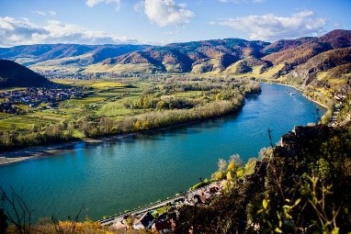  Curriculum Grid  Autumn 1  Y3/4 |  | Science  Our focus for science this term is Rocks. We will be comparing and grouping different kinds of rocks based on their appearance and physical properties (igneous, sedimentary and metamorphic). By the end of the unit the children will be able to explain how fossils are formed and how soil is made. They will also be investigating different rocks and soils within our local environment. We will be encouraging the children to work scientifically by reporting their findings in a variety of ways. They will be able to identify differences, similarities or changes within an experiment. |  |  |  |  | 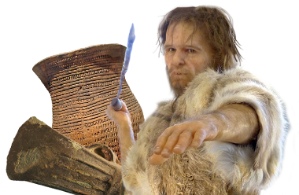  Through the Ages
French  In French, this half-term, we will be learning about phonics and completing a theme entitled: ‘I’m learning French’. There will be a number of different activities to improve our cultural awareness of France and French speaking countries. Finding France and locating Paris on a map. Plenty of oral role play tasks to ask how somebody is feeling and replying using all three options. Learning ten colours and a song and be able to count from 1-10 in French. | Art  In art, we will be completing a project on Bell Beaker pottery. It allows the children to explore different clay techniques, which they use to make and decorate a Bell Beaker-style pot. They will explore pots that were made and then design and draw their own ideas in their art sketchbooks, before having a go at creating them out of clay. |  | Music  Music will be focused around the song ‘Let your spirit fly’. By the end of this unit, we will know five songs from memory and who sang them or wrote them. We will know the style of the five songs. We will be able to choose one song and be able to talk about: Its lyrics: what the song is about; Any musical dimensions featured in the song, and where they are used (texture, dynamics, tempo, rhythm and pitch). We will be able to identify the main sections of the song (introduction, verse, chorus etc.); Name some of the instruments they heard in the song; We will confidently identify and move to the pulse; We will think about what the words of a song mean; We will take it in turn to discuss how the song makes us feel. We will listen carefully and respectfully to other people’s thoughts about the music. We will also have our harvest celebrations during this half-term. |  |  | Computing  In computing, we are going to be learning all about ‘connecting computers’. We will develop our understanding of digital devices, with an initial focus on inputs, processes, and outputs. We will also compare digital and non-digital devices. Next, we will be introduced to computer networks, including devices that make up a network’s infrastructure, such as wireless access points and switches. Finally, we will discover the benefits of connecting devices in a network. |  |  | P.E.  In P.E. this half-term, we will be completing commando Joe activities whilst the weather is still fair. We will also be learning invasion games.  Children will need to come in their P.E. kits on Monday and Wednesday each week.

Links to our curriculum drivers Danube Class Autumn 1 Y3/4
The following drivers underpin our school curriculum and, with our vision and values, allow us to deliver our curriculum strategy. These key drivers are personal to our schools and reflect the locational, social and educational needs of our community.
Curriculum Driver | Links within our curriculum this half term
Christianity and Faith | - R.E. - The Creation story and the fall.  - R.E. Leaders  - Harvest Celebrations at our local church
Our Local Area | - Cross country for KS2  - Science – environment around us
Outdoor Growing, Learning and Environment | - Eco Schools Representatives  - Maths – showing place value in nature  - Science – Investigating plants  - PE – Using our outdoor spaces
Wider World and Diversity | - PSHCE/RE – being me – Making positive friendships and being able to recognise and seek support if needed.  - School Council  - French – Learning about a different language  - Music from other cultures – rhythm and blues.  - Computing – networking/online safety  - Sport Crew

