English  Our class texts are books by Giles Andrea– our significant author.  Our guided reading text is Greta and the Giants.  We will also be reading poetry by the author Allan Ahlberg. Scissors Please Mrs Butler.  Our writing styles for this half-term are:  Instructions.  Recounts.  Poetry.  Letters  We will have our Little Wandle reading sessions as well as our daily phonics sessions. | R.E.  In RE we will be looking at Incarnation.  We will be learning to:  Tell the story of Jesus’ birth.  Identify different texts from the bible.  Give accounts of what Jesus’ birth means to Christians.  Think, talk and ask questions about the Christmas story and the lessons they might learn from it. We will also be performing our Nativity play at Christmas time. |  | Maths  In Maths during this half-term, our objectives will focus on geometry and addition and subtraction:  We will be learning to:  Recognise and name 2D and 3D shapes. We will sort shapes depending on their properties and explain how we have sorted them.  Year 1 will be looking at:  Using part whole models, writing number sentences, number bonds to 10, fact families and understanding the addition, subtraction and equals symbol.  Year 2 will be looking at:  Use a place value chart.  Compare objects and numbers.  Practise addition and subtraction.  Use related facts to solve problems.  Compare number sentences. |  |  | History  In History, we are finding out about Significant People.  We will be learning about:  George Stephenson.  Historical models, such as Dawson's model.  How historical information can be presented in a variety of ways. Such as chronological order and non-chronological.  Timelines to show different periods of time from a few years to a million years ago. We will be learning about significant explorers like Neil Armstrong and Christopher Columbus.  Movers and Shakers  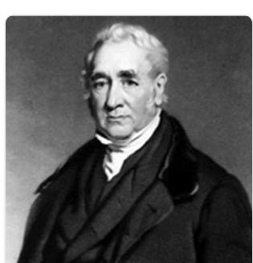
PSHE/RSE  This half term is all about  Celebrating differences.  We will learn that people have different roles in the community to help them (and others) keep safe - the jobs they do and how they help people.  who can help them in different places and situations; how to attract someone’s attention or ask for help; what to say. |  | 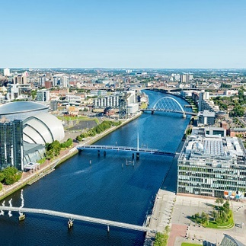  Clyde Class  Curriculum Grid  Autumn 2 Y1/2 |  | Science  In Science this half-term, we will be finding out about Plants. We will be working Scientifically.  We will ask questions and recognise that they can be answered in different ways. We will use simple equipment to make observations and perform simple tests. We will gather and record data to help us to answer questions.  We will use scientific language to talk about our findings.  We will also look at how the seasons change from Autumn to Winter. |  |  | Geography  In Geography, we will name and locate the seas which surround the United Kingdom. We will learn that compass points give us a location. We will use aerial photographs to identify physical and human features on maps. We will also be comparing the features of coastal areas with our local area.
Design and Technology  Chop, Slice and Mash.  We will explore: Where food comes from. We will select from and use a range of tools and equipment to perform practical tasks (for example, cutting, shaping, joining and finishing). We will use the basic principles of a healthy and varied diet to prepare dishes. We will design a supermarket sandwich based on design criteria. |  | Music  We will listen to In The Groove by Joanna Mangona – an easy-to-learn song that demonstrates different styles of music.  six different styles; Blues, Baroque, Latin, Bhangra, Folk and Funk. Each week we will listen and learn a different style of In The Groove. We will also explore using musical instruments to accompany each style of music.  We will also have whole school singing practice. We will also be beginning to prepare for our Nativity Christmas production. |  |  | Computing  In Computing, we are going to be looking at digital painting.  We will develop their understanding of a range of tools used for digital painting. We will then use these tools to create our own digital paintings, while gaining inspiration from a range of artists’ work. The unit concludes us considering our preferences when painting with and without the use of digital devices. |  | P.E.  In PE we will continue to have some sessions with NUFC. We will practise gymnastics. We will master basic movements including running and jumping as well as developing balance, agility and co-ordination. We will discover ways of travelling using body parts. We will refine ways of moving using body tension.  PE Kit should be worn on Tuesday and Thursday  Year 2 will be doing forest schools on Thursday so will need to bring their wellies and waterproofs on this day.

Curriculum Driver | Links within our curriculum this half term
Christianity and Faith | RE. We will be celebrating Remembrance Day. We will also look at the Christmas story and performing a Nativity of this to our community.  Christingle service at our local church
Our Local Area | Science -investigations about woodlouse habitats. History - George Stephenson – a local inventor who lived in nearby Wylam  Geography - We will look at physical and human features on maps of our local area
Outdoor Growing, Learning and Environment | Science. We will be carrying out a range of scientific investigations in the outdoor area  Eco Schools Representatives improving our school environment.  English. In English we will be reading Greta and the Giants and looking at human influences on our planet and how we can help.
Wider World and Diversity | English - We are looking at the story Greta and the Giants by Greta Thunberg and the impact of deforestation.  PSHE - We will celebrate difference and recognise different roles in the community. We will also look at PSHE. We will celebrate difference and recognise different roles in the community.  Understanding protected characteristics during Anti-bullying day  World Cup day – Learning about traditions and cultures from another country.  Geography: Looking at RNLI around the UK and understand why they are important.  Science: linked to science investigations about ice and why talk about why it is useful for people to know how to slow down or speed up the melting of ice.
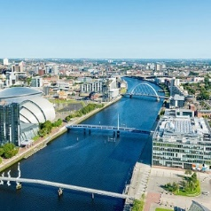
Links to our curriculum drivers Clyde Class Autumn 2 Y1/2

The following drivers underpin our school curriculum and, with our vision and values, allow us to deliver our curriculum strategy. These key drivers are personal to our schools and reflect the locational, social and educational needs of our community.

