Autumn 1: Rocks
Year 3: Foundational Skills
- Rock Groups: I can identify and name the three main types of rock: igneous, sedimentary, and metamorphic.
- Properties & Grouping: I can look at different rocks and group them based on simple properties, like their colour, texture, or how they look.
- Fossil Formation: I can use a simple, labelled diagram to show the basic steps of how a fossil is formed.
- Soil Composition: I can identify what soil is made of and explain that it contains tiny bits of rock and organic matter.
- Local Exploration: I can explore and identify different types of rocks and soils in our local playground or nearby environment.
- Legacy: I know who James Hutton was and understand that he is a famous figure in the study of geology.
Year 4: Complex and Comparative Skills
- Rock Groups: I can explain the scientific differences in how igneous, sedimentary, and metamorphic rocks are formed over time.
- Properties & Grouping: I can set up a fair test to compare and classify different rocks based on physical properties like hardness, density, or permeability.
- Fossil Formation: I can use a detailed, labelled diagram to explain the complex geological process of fossilisation over millions of years.
- Soil Composition: I can explain the scientific process of how soil is created when rocks break down and mix with decaying organic material.
- Local Exploration: I can record, compare, and analyze the characteristics of different rocks and soils collected from our local environment.
- Legacy: I can explain exactly how James Hutton’s ideas revolutionized the study of geology and changed our understanding of the Earth's history.

Autumn 2: Working Scientifically
**Year 3: Foundational Skills **
- Using Equipment: I can use basic scientific equipment like stopwatches, beakers, and thermometers to make simple observations and measurements.
- Recording Data: I can write down and record my experiment results using simple notes and tables with standard units.
- Presenting Data: I can display the information I gather using simple, labelled drawings or a basic bar chart.
- Investigating: I can write down the main parts of an experiment, including my prediction, what I did, and what I found out.
- Identifying Changes: I can look at an experiment and point out simple similarities, differences, or things that changed.
- Legacy: I know who Marie Curie was and can name one of her famous achievements.
Year 4: Complex and Comparative Skills
- Using Equipment: I can independently select and use a range of advanced equipment, including digital data loggers, stopwatches, and thermometers, to take highly accurate measurements.
- Recording Data: I can organize and record my experimental data systematically using structured tables and precise standard units.
- Presenting Data: I can choose the best way to present my data to others, using complex methods like classification keys, detailed line graphs, bar charts, or tables.
- Investigating: I can independently write a full, formal scientific investigation, detailing the aim, prediction, method, results, and a reasoned conclusion.
- Identifying Changes: I can analyze multiple test results to explain exactly why specific differences, similarities, or changes occurred in an experiment.
- Legacy: I can evaluate how Marie Curie’s discoveries changed the scientific world and explain why her legacy remains so important today.

**Spring 1: Forces and Magnets **
Year 3: Foundational Skills
- Surface Friction: I can observe and describe how a toy car moves differently across surfaces like carpet, wood, sand, or ice.
- Contact Forces: I can identify that some forces only work when two objects are physically touching.
- Magnetic Distance: I can show on a simple diagram that magnets can pull or push objects without actually touching them.
- Magnetism Test: I can test different everyday items to see if they attract to a magnet and group them based on my findings.
- Attract & Repel: I can predict if two magnet poles will attract or repel each other and test my prediction.
- Legacy: I know who William Gilbert (spelled William Gilber in your sources) was and that he discovered important facts about magnetism.
**Year 4: Complex and Comparative Skills **
- Surface Friction: I can analyze and compare how friction changes when an object moves across distinct surfaces, explaining why some cause more resistance than others.
- Contact Forces: I can explain the specific scientific differences between contact forces, including reaction force, tension, friction, and air resistance.
- Magnetic Distance: I can use a detailed scientific diagram to explain how non-contact magnetic forces can act across a distance.
- Magnetism Test: I can classify materials as magnetic or non-magnetic and explain why metals like iron attract to magnets while other materials do not.
- Attract & Repel: I can use the scientific rules of magnetic poles to accurately predict and explain how different magnets will interact with each other.
- Legacy: I can explain how William Gilbert’s early discoveries laid the foundation for our modern understanding of magnetism and the Earth's magnetic field.

Spring 2: Animals (Including Humans)
Year 3: Foundational Skills
- Nutrients: I can name the main nutrients that animals need to survive, such as water, carbohydrates, and protein, and identify what they do.
- Nutrient Needs: I can identify that different animals—and humans at different ages—need different amounts of food and nutrients to stay healthy.
- Food Chain Roles: I can point out which organisms are the producer, predator, and prey in a basic food chain.
- Creating Food Chains: I can put a simple food chain together and explain how it works.
- Legacy: I know who Charles Elton was and that he invented a system to study food chains.
Year 4: Complex and Comparative Skills
- Nutrients: I can explain the specific biological functions of water, carbohydrates, protein, fibre, fats, vitamins, and minerals in keeping animals healthy.
- Nutrient Needs: I can compare and evaluate how nutritional and dietary requirements change as a human grows from a baby to an adult.
- Food Chain Roles: I can define the ecological roles of producers, predators, and prey, and explain how they rely on each other to survive.
- Creating Food Chains: I can construct complex food chains and write a detailed explanation of how energy flows from one living thing to another.
- Legacy: I can explain the significance of Charles Elton’s food cycle theories and evaluate how his models changed our understanding of animal habitats.

Summer 1: States of Matter
Year 3: Foundational Skills
- Three States: I can sort a variety of common materials into solids, liquids, or gases.
- State Behaviour: I can describe what makes a material a solid, liquid, or gas, giving simple examples of each.
- Changing States: I can observe and describe what happens to water when it freezes into ice or to chocolate when it melts.
- Temperature Test: I can help design a simple test to find out what temperature water changes state.
- Water Cycle Basics: I can explain what evaporation, transpiration, and condensation mean.
- Cycle Diagram: I can point out where evaporation and condensation happen in a simple diagram of the water cycle.
- Legacy: I know who Anders Celsius was and how his work affects how we measure temperature today.
Year 4: Complex and Comparative Skills
- Three States: I can compare and group a range of materials together, explaining how the particles in solids, liquids, and gases behave differently.
- State Behaviour: I can explain how heating or cooling forces a material to change state, using correct scientific terms like melting, freezing, evaporating, and condensing.
- Temperature Test: I can design and execute a fair, systematic test to measure and record the precise temperatures at which water changes state.
- Water Cycle Basics: I can explain the physical processes of evaporation, transpiration, and condensation in detail.
- Cycle Diagram: I can build a detailed scientific diagram to explain exactly how evaporation and condensation drive the global water cycle.
- Legacy: I can explain how Anders Celsius’ work on temperature scales remains highly important to modern daily life and scientific research today.

Summer 2: Electricity
Year 3: Foundational Skills
- Power Sources: I can identify which common household appliances run on mains electricity and which ones run on batteries.
- Circuit Parts: I can identify and name the basic parts of a simple circuit, including the battery, wire, switch, and lamp.
- Building Circuits: I can put together a simple, working series circuit to make a bulb light up.
- Circuit Predictions: I can look at a simple circuit and make a prediction about whether the bulb will light up or not.
- Conductors & Insulators: I can test different materials in my circuit to find out if they are electrical conductors or insulators.
- Switches: I can show that a switch can open and close a circuit to turn a light on and off.
- Legacy: I know who Thomas Edison was and what major invention he created.
Year 4: Complex and Comparative Skills
- Power Sources: I can explain the scientific differences in voltage, safety, and function between mains electricity and battery-powered appliances.
- Circuit Parts: I can identify, name, and explain the roles of batteries, switches, lamps, buzzers, motors, and wires within an electrical circuit.
- Building Circuits: I can systematically construct a series circuit, explain how electricity flows through it, and troubleshoot why a circuit might not be working.
- Circuit Predictions: I can write a detailed scientific explanation to justify my prediction of whether a complex series circuit will successfully function.
- Conductors & Insulators: I can explain the physical differences between electrical conductors and insulators, using evidence from my experiments to support my claims.
- Switches: I can explain the mechanical function of a switch in opening and closing a circuit to safely control the flow of electric current.
- Legacy: I can explain exactly what Thomas Edison invented and evaluate how his work changed the modern world.

Autumn 1 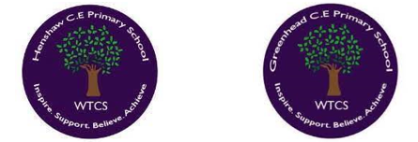
Year 3.4
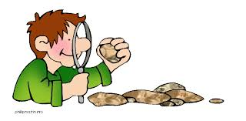
Rocks
- I can explain what the terms igneous, sedimentary and metamorphic mean.
- I can compare and group different kinds of rocks based on their appearance and physical properties.
- I can explain how fossils are formed, using a simple, labelled diagram.
- I can explain how soil is made and what it is made from.
- I can explore different rocks and soils within our local environment.
- LEGACY – I know who James Hutton was and how he changed the study of Geology.

Golden Scientific Threads
- Enquiry – What scientific questions have we asked & answered?
- Observation – How have we observed science in practice?
- Evidence – What evidence have we researched or found out from our own experiments?

Autumn 2
Year 3.4
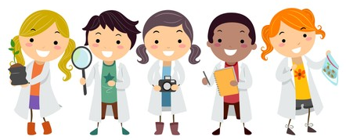
Working Scientifically
- I can use a range of equipment to make observations and accurate measurements. (Use data loggers, stopwatches, beakers or thermometers)
- I can gather and record data in a variety of ways. (Using notes, tables and standard units),
- I can present data in a variety of ways (labelled diagrams, keys, bar charts and tables).
- I can write a full, scientific investigation (Aim, prediction, method, results and conclusion)
- I can identify differences, similarities or changes within an experiment.
- I can find evidence for an investigation to answer my questions.
- LEGACY – I know who Marie Curie was and how she changed the world.

Golden Scientific Threads
- Enquiry – What scientific questions have we asked & answered?
- Observation – How have we observed science in practice?
- Evidence – What evidence have we researched or found out from our own experiments?

Spring 1
Year 3.4
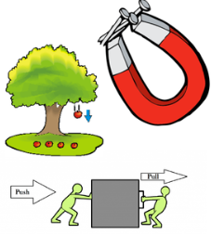
Forces and Magnets
- I can compare how objects move on different surfaces (sandpaper, carpet, ice, wooden floor).
- I can explain how some forces need contact between 2 objects. (reaction force, tension, friction and air resistance).
- I can explain that magnetic forces act at a distance (show by a simple diagram).
- I can group and compare everyday materials based on whether they attract to a magnet or not, explaining this as magnetism.
- I can make a prediction about whether two magnets will attract or repel, then test this prediction.
- LEGACY – I know who William Gilber was and what he discovered about magnetism.

Golden Scientific Threads
- Enquiry – What scientific questions have we asked & answered?
- Observation – How have we observed science in practice?
- Evidence – What evidence have we researched or found out from our own experiments?

Spring 2
Year 3.4
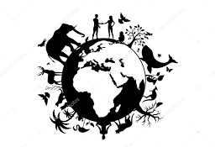
Animals (Including Humans)
- I can identify what nutrients animals need to survive. (water, carbohydrates, protein, fibre, vitamins and minerals and fats) and what these nutrients do.
- I can compare how the amount and types of nutrients humans need change as they get older.
- I can identify producer, predator and prey within a variety of food chains.
- I can construct a variety of food chains, myself, explaining how these work through written explanations.
- LEGACY: I know who Charles Elton was and can discuss what he invented regarding food chains.

Golden Scientific Threads
- Enquiry – What scientific questions have we asked & answered?
- Observation – How have we observed science in practice?
- Evidence – What evidence have we researched or found out from our own experiments?

Summer 1
Year 3.4
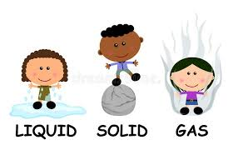
States of Matter
- I can compare and group materials together according whether they are gases, liquids or solids.
- I can explain what makes a material a solid, liquid or gas, giving examples of each.
- I can observe and explain how some materials change state. (heated or cooled: ice to water, chocolate from solid to liquid)
- I can design a test, finding out what temperatures changes the state of water.
- I can explain the process of evaporation, transpiration and condensation.
- I can identify how evaporation and condensation play a part in the water cycle. (show on a diagram)
- LEGACY – I know who Anders Celsius was and how his work still has an effect on us today.
Golden Scientific Threads
- Enquiry – What scientific questions have we asked & answered?
- Observation – How have we observed science in practice?
- Evidence – What evidence have we researched or found out from our own experiments?

Summer 2
Year 3.4
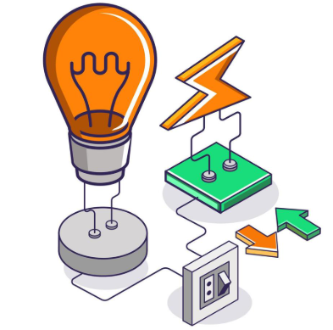
Electricity
- I can identify common appliances that run electricity and common appliances that run from batteries.
- I can identify and name basic parts of series electric circuit (batteries, switches, lamps, buzzers, motor and wires)
- I can construct a simple series electrical circuit and describe how this works.
- I can predict if a lamp will light up in a simple series, giving an explanation for my prediction.
- I can recognise some common conductors and insulators and test these materials out in an experiment.
- I can recognise and test that a switch opens and closes a circuit.
- LEGACY – I know who Thomas Edison was and what he invented.

Golden Scientific Threads
- Enquiry – What scientific questions have we asked & answered?
- Observation – How have we observed science in practice?
- Evidence – What evidence have we researched or found out from our own experiments?

