***Greenhead CE Nursery and Primary School Newsletter***

**Newsletter No. 8 Spring Term 2024**

**Friday 8th March**

**Greenhead**

**West Tyne Federation of Schools Northumberland**

**Executive Headteacher - Mr Mike Glenton NPQH, MEd, BSc (Hons) CA8 7HB**

**Assistant Head Teacher – Mrs Sherry Makepeace, BSc (Hons) Tel 016977 47347**

**Workshop Wednesday/Easter Celebrations**

A quick reminder that Workshop Wednesday is coming up next week from 9am to 10am. Also our Easter celebration at St Cuthbert’s Church in the last week of term, will be held on **Tuesday 26th March** at 2pm and parents/carers are welcome to come back to school afterwards for a cup of tea, coffee and biscuits! We will also be showcasing the wonderful entrants to our yearly Easter Egg competition for all to see.

**A Message from the Head Teacher**

We are heading into March already, I’m not too sure where this year has gone and we are only three weeks away from Easter holidays. World Book Day was another wonderful event with lots of different costumes and activities for the children to celebrate reading and stories. We all enjoyed the treasure hunt, a visit from our local library and an online webinar with a real-life author!

We really are fortunate at Greenhead Primary School to have such small class sizes of between 10 – 14 children per class. Other schools cannot offer this provision and often a teacher is shared between 30+ children. Having such small classes allows us to offer a tailored curriculum to our pupils as well as children accessing much more teacher time because of the low adult:child ratios. We are also able to combine classes easily at times so that more of our pupils benefit from specialist teaching and learning opportunities. Due to this, the progress we are seeing pupils make is fantastic; they really are a credit to their families.

Best wishes, Mr Glenton

**Technology update**

You may have seen that we have recently been able to purchase 10 new iPads for our school which have been added to the 16 laptops that we purchased last academic year. Technology at Greenhead Primary School has really developed over the past few years, with a progressive curriculum of computing now embedded into our practice; it astounds us what our children can accomplish and what they know about the use of technology in lessons and discussions!

Early Years

Eden class enjoyed a visit to the Great North Museum to start off our Dinosaur topic. The children learnt about how fossils are formed and took turns to find, identify and measure them. In literacy we read the story Dear Dinosaur and have written post cards to our favourite Dinosaur using our phonics skills. In maths we have begun exploring measurement using non-standard units. The children have measured the height and length of a range of dinosaurs, created a class height chart and created different sized worms using the vocabulary longest and shorter. At home can your child make different length worms using playdough? There are some great measurement games online to encourage mathematic language and thinking, type in: [Let's Compare - Early Years Size Comparison Game (topmarks.co.uk)](https://www.topmarks.co.uk/early-years/lets-compare) to any search engine to find out more

Clyde Class

This week we have been looking at features of diary entries and started to plan our own diary entry linked to the Great Fire of London. In Maths Year 1 have been exploring fractions by representing half of a shape or quantity. Year 2 have been exploring odd and even numbers. To support your child at home, explore fractions by halving sandwiches or pizzas or sharing toys out equally.  In Science we had great fun looking at a range of materials and grouping them by their properties. During PE we have been busy practising our dance for the Dance Festival. In RE we have started to discuss why Easter is important to Christians and identified any signs of Spring.

Danube Class

The children have been working really hard in Danube class this week. In maths we have been continuing to learn about fractions. Year 3 have been ordering fractions using number lines. Whilst Year 4 have been converting mixed numbers into improper fractions. The children have been creating their (Roald Dahl) 'Witches' inspired newspaper reports in English. Continuing our D.T project the children have been finishing constructing cards which have a simple mechanism in their design. Please continue to read with the children and support them with their times tables and spellings at home.

Mississippi Class  
In English last week, Mississippi class worked in pairs to perform 'You are Old, Father William' by our class author, Lewis Carroll. This week, we have worked hard to produce biographies about Robert Peel - ask your child if they can tell you why he is significant and what his legacy is. In Science, we have begun our new topic of Properties of Materials and have learned all about how states of matter change and what it means for something to be magnetic. Please continue to

encourage your child to access Spelling Shed every week, they should practice each spelling 15 times a week.

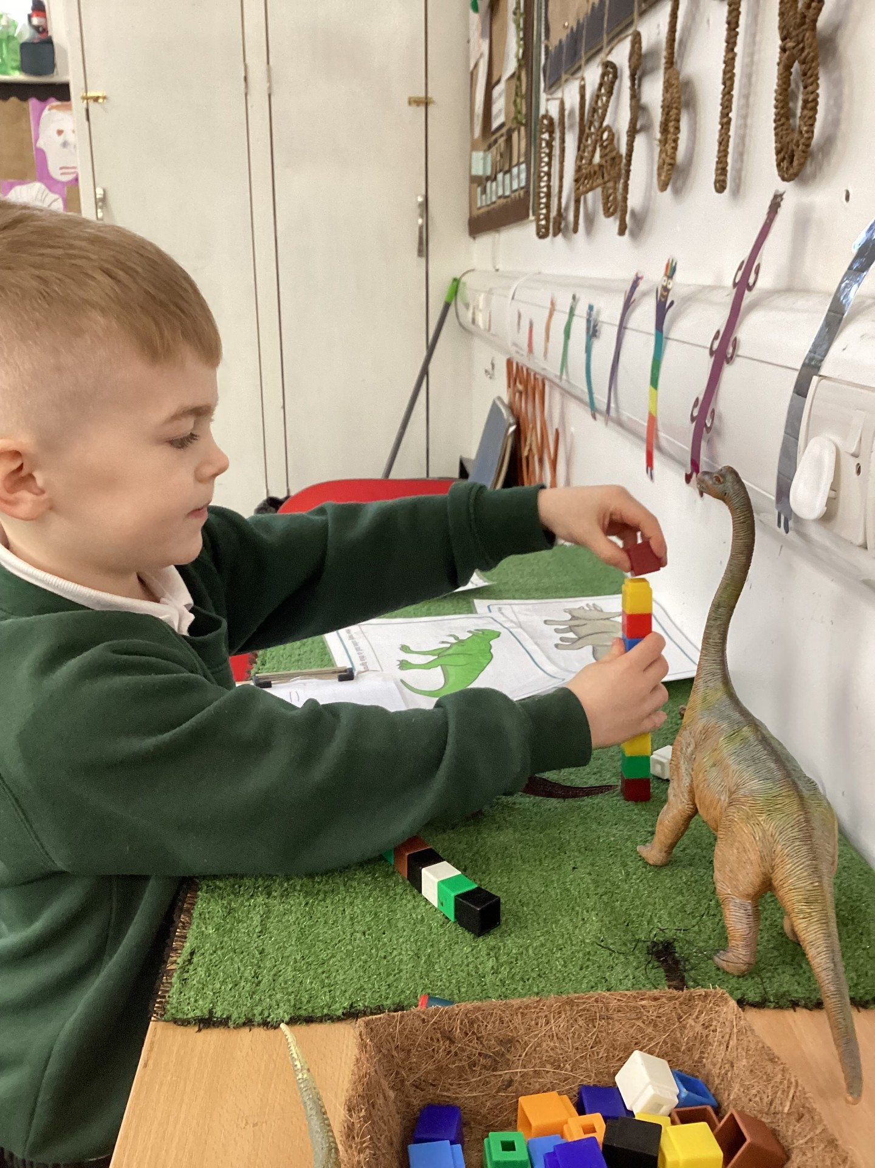

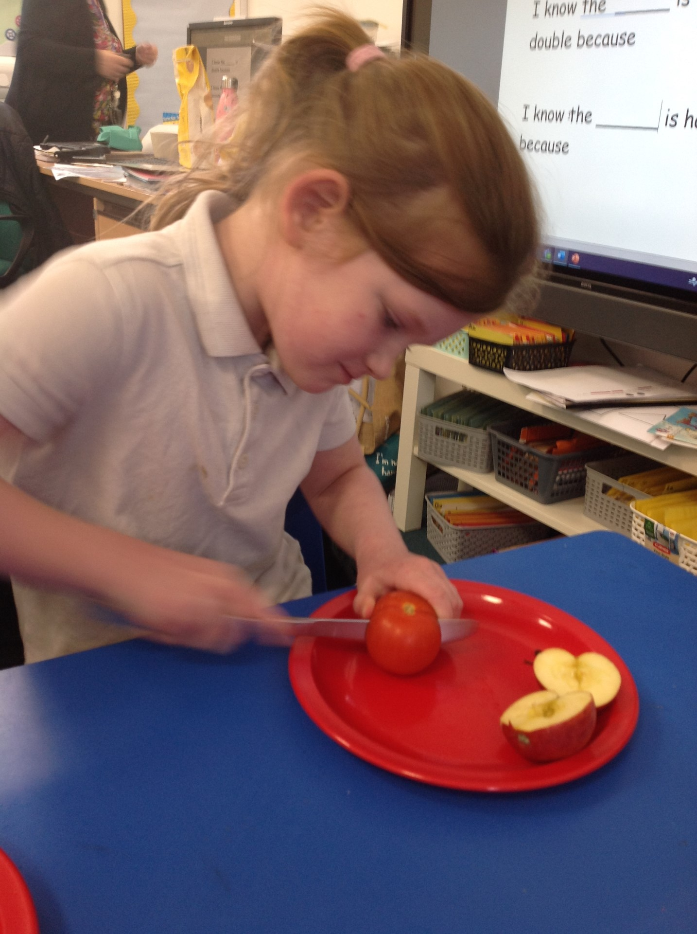

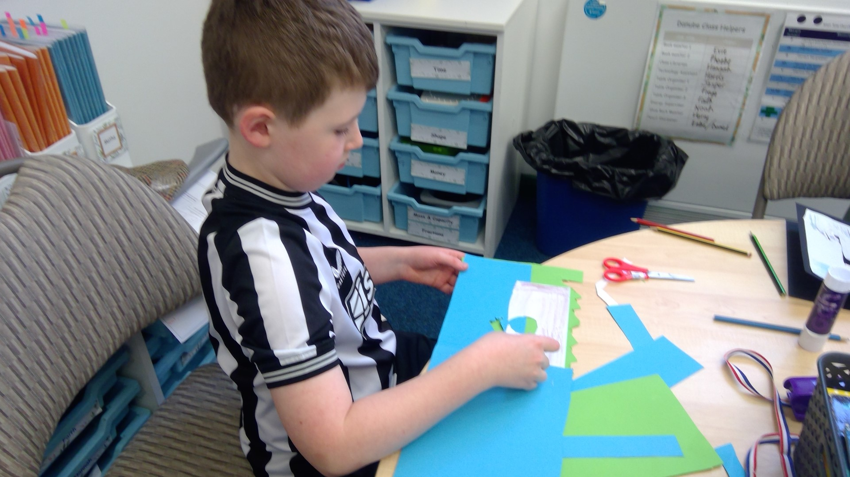

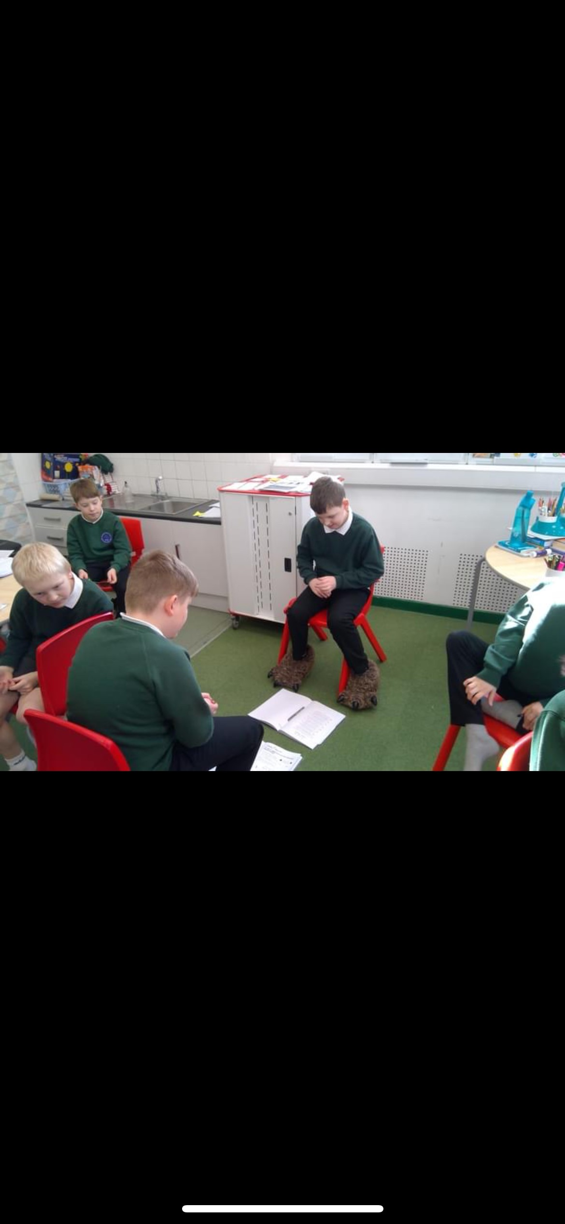

**Class News**



**Staffing update**

It is with sadness that Mrs Mitchell will be leaving us at the end of this term to take up a position at Bellingham Middle school. I would like to take this opportunity to thank Mrs Mitchell for developing our Forest School provision at Greenhead Primary and wish her every success as she progresses in her new role.

Mrs Porteous will become a full time teacher at Greenhead for the summer term, teaching Year 3 and 4 all week, from Monday to Friday.

**Our School Promise**

Our School Promise reminds us of our vision and values that we hold dear at The West Tyne Church Schools Federation.

Well done to the following children for achieving their awards:

**Learning Award – Cadence & Owen**

**Resilience & Teamwork Award – Charlie**

**Etiquette Award – Oscar**

**Environmental Award – Hope**

**Kindness Award – Phoebe**

**Inclusion Award – Daniel**

**Friendship Award – Fraser**

**Role model Award – Lily**

Attendance: Every day is important to give children their full entitlement to an exciting learning journey

|  |  |
| --- | --- |
|  | Eden – 86% |
| Clyde – 90.91% |
| Danube - 84.55% |
| Mississippi – 90% |
| **Whole School – 89.8%** |

**Our school target for attendance is 96%**

**Dates for the Diary**

**Tuesday 12th March** – Year 1.2 visit to Susan’s Farm

**Tuesday 12th March** – Year 5.6 visit to Newcastle United Football Club

**Wednesday 13th March** – Workshop Wednesday, all parents welcome to attend, 9am – 10am

**Tuesday 19th March** – The Great British Spring Clean (organised by the Eco Council)

**Tuesday 19th March** – Irish dancing display to the school

**Tuesday 26th March** – Easter Celebration at St. Cuthberts Church 2pm, all welcome

**Thursday 28th March –** Federation Dance Festival at Haltwhistle leisure centre

**Thursday 28th March** – Last day of school before Easter holidays

Easter holidays: Friday 29th March until Sunday 14th April

**Monday 15th April** – First day of summer term

**Year 3 and 4 will attend swimming lessons each Tuesday after the Easter holidays, starting on Tuesday 16th April**

**A final thought…**

**If you want to support others, you have to stay upright yourself**

Peter Hoeg

**Schools 360 for Nursery and Reception**

Just a reminder to parents and carers of our Nursery and Reception children that your child’s learning journey and experiences in the Early years is recorded on our online platform, Schools 360. You should have access to this platform, where you can look through the observations made by teaching staff and your child’s next steps. It also gives you the opportunity for you and your child to upload your own activities at home to share with the class teacher.

**Greenhead Nursery**

Our Nursery at Greenhead Primary School continues to grow and the provision that is offered by our wonderful teaching assistants; Mrs Brachtvogel and Mrs Liddle is fantastic, as is the leadership of Early Years by the fantastic Mrs Thompson. With our forest school area (which our resident chickens Lillibet and Phillipa live in), physical development garden, well-resourced indoor provision and outside playground quad (including lots of balance bikes), the Nursery is a great place for our children to start their learning journey with us.

We now have limited spaces for the rest of the academic year. If you or anybody you know requires Nursery provision, please do get in contact as soon as possible. Remember; the funding for 2, 3 and 4 year old placements in Nursery has been improved with children now entitled to 15 to 30 hours funded placements.