Science in Lower KS2 Cycle B
Plants
- I can identify/describe functions of different parts of flowering plants (roots, stem/trunk, leaves & flowers)
- I can explore the requirements of plants for life and growth (air, light, water, nutrients from soil and room to grow) and how they vary from plant to plant (beech tree, cactus, money plant, ivy, nettle)
- I can investigate ways in which water is transported in plants (using food dye, white carnations and celery)
- I can explore the part that flowers play in the life cycle of flowering plants (pollination, seed formation and seed dispersal.)
Working Scientifically
- I can ask questions and use different types of scientific enquiries to answer them.
- I can set up simple practical enquiries, comparative and fair tests.
- I can record findings using simple scientific language, drawings, labelled diagrams, keys, bar charts and tables.
- I can use results to make simple conclusions and suggest improvements and raise further questions.
Light
- I can describe how we see objects in light and can describe dark as the absence of light
- I can explain why it is dangerous to view the sun directly and state precautions used (Sunglasses and visors).
- I can define transparent, translucent and opaque and give examples of what has these qualities (water, glass, metal, stone, sunglasses, tissue paper)
- I can describe how shadows are formed and explore making and measuring shadows in different ways (using torches, sunlight, puppets)
- I can explain what happens when the light source moves or the distance between the light source and the object change.
Sound
- I can name sound sources and state that sounds are produced by the vibration of the object. (Musical instruments, saucepan lids, elastic bands)
- I can recognise that vibrations from sounds travel through a medium to the ear.
- I can find patterns between the pitch of sound and features of the object that produced it. (The shorter, tighter or thinner the object is, the higher the pitch of the sound will be).
- I can find patterns between the volume of a sound and the strength of the vibrations that produced it. (Hit the drum harder, the vibration is stronger).
- I can recognise that sounds get fainter in relation to distance.
Animal, including humans
- I can give at least four examples of animals (including humans) that have skeletons and muscles for support, protection and movement. (Chicken, cows, horse, shark)
- I can name at least four bones within the boy that protect us. (Ribs, pelvis, sternum, skull).
- I can describe the simple functions of the basic parts of the digestive system in humans (mouth, tongue, teeth, oesophagus, stomach, and small and large intestines in a diagram).
- I can identify different types of teeth in humans. (Canines, incisors, pre-molars and molars).
- I can explain the function of at least two different types of human teeth.
Living things and their habitats
- I can group living things in a variety of ways. (animals/ non-flowering plants /flowering plants, vertebrate animals/ invertebrates, animals,
- I can explore and use a classification key to help me identify a variety of living things in our local area.
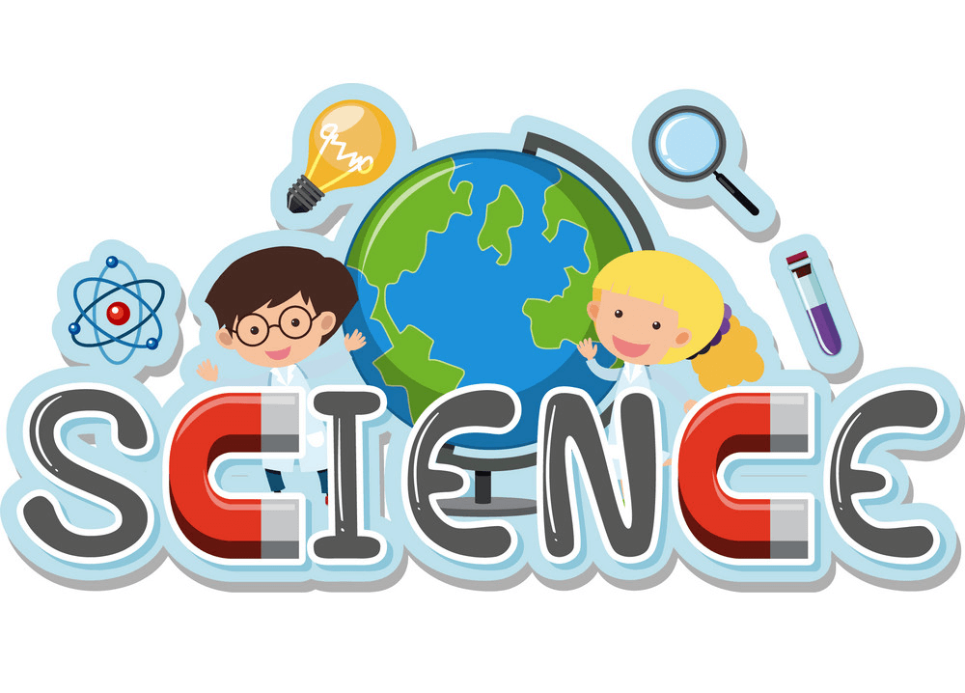
- I can explain and give examples of how environments can change (both positive and negative) due to human and natural impact. (Pollution, litter, deforestation, ecologically planned, protecting habitats).
- I can suggest ways to help protect habitats and research into conservation projects in my local area.

