Personal Social & Emotional Development  In PSED this half term we will be exploring our hopes, dreams and aspirations. We will begin by thinking about our new year’s resolutions – what do we want to learn to do or get better at this year. Where appropriate for school these will feed into our daily activities. We will learn about The Power of Yet to remind us about resilience and never giving up. We will build our resilience through our Commando Joes activities. We will read stories such as ‘The Little Engine that Could’ about not giving up. We will read the story ‘Giraffes Can’t Dance’ and will discuss and encourage positive attitudes to learning – how life is better when we are motivated, curious, enthusiastic, with a can-do attitude. |  | R.E.  In R.E. this half-term, we will be learning how God entrusted man to look after our wonderful world. We will discuss how this is a big responsibility. We will think about what we need to look after in our world e.g. the animals, and how we can help with this. We will learn about ‘Umaganda’ and will write a letter to our school council to suggest our own ‘Umaganda’ for our school which we will help with. |  | Physical Development  In P.E. this half-term, we will be focusing on Gymnastics. We will enjoy a range of PD activities including Dough disco and Squiggle while you wiggle. We will use meditation and yoga to further strengthen our bodies and learn how to relax. We will take part in weekly Commando Joes activities which promote physical and PSED skills.  Children will need to come in their P.E. kits on Monday and Wednesday each week.
Eden Class  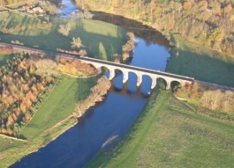  Curriculum Grid  Spring 1  ‘A Starry Night’ | Literacy  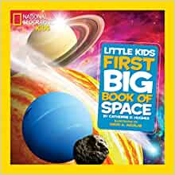  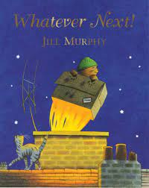  This half term we will be looking at the features of non-fiction books. We will use these to learn about Space. We will enjoy a range of stories about space such as Whatever Next! and How to Catch a Star. We will also be exploring what happens at night when we are sleeping e.g. learning about nocturnal animals.  We will be paying attention and responding to the pictures and the words and will practise articulating our thought and ideas in well-formed sentences. We will invent our own stories based on stories we know. We will ‘hot seat’ a character from a story.  In phonics we will continue to learn and develop our knowledge and understanding of sounds, letters and words through our Little Wandle programme. We will use the phonemes we have learnt to read and write simple words. We will begin to explore capital letters and finger spaces. In class we encourage mark making and early and developing writing for difference purposes e.g. a list of items to take into space, labelling planets for a fact file. |  |  |  | Understanding the World  This half term we will learn about the Chinese zodiac and how Chinese New Year is celebrated. We will cook and taste some traditional Chinese food.  We will explore the natural world around us and understand important processes and changes in the natural world, including how seasons change and changes in matter e.g. water freezing. We will explore differences in the world at night compared to during the day.  We will enjoy weekly Forest School sessions.  We will conduct some science experiments and continue to learn about fair testing, predicting and collecting data. We will explore shadows using the sun and torches.
Expressive Art and Design  This half-term we will continue to use different tools and materials to express our ideas through art, construction and modelling. We will create our own space ship and props to go in it. We will create dens and tents to help us to explore light and dark, learning about how to attach materials.  Our focus artist with be Andy Warhol. We will create our own space pictures in his pop art style.  We will join in with role-play and storytelling and will develop storylines in our pretend play using and making our own props.  In Music we will join in with whole school singing. In class we will learn new action rhymes and songs to explore rhythm, pitch and volume through our singing and also through playing some percussion instruments. |  |  | Maths  In maths this half term we will continue our maths mastery journey through maths talk, practicing the skills we've learned during play and developing number sense.  We will be:  * Joining in with our daily calendar, learning the days of the week, months of the year and the seasons.  *Sequencing daily events and sorting daytime and night time activities.  *Singing number songs and rhymes and playing number games.  *Matching, sorting and comparing amounts.  * Counting, representing, comparing and understanding the composition of numbers 7, 8, 9, 10.  * Learning about pairs and early doubling.  *Combining two groups.  *Comparing size – length and height, mass and capacity.

Links to our curriculum drivers Eden Class Spring 1 Reception
Curriculum Driver | Links within our curriculum this half term
Christianity and Faith | - R.E. – How God entrusted man to look after our world – the Bible stories that talk about this  - Umaganda – Christian traditions around the world  - Exploring Christianity and our own beliefs  - PSED – Hopes, beliefs and aspirations  - Umaganda for our school – looking after and improving our local environment
Outdoor Learning and the Local Environment | - Forest School – exploring our local environment  - Maths in nature  - Changing seasons – freezing and melting  - Eco Council – environmental pledge – feeding the birds
Wider World and Diversity | - PSED – exploring our hopes, dreams and aspirations  - School Council  - Chinese New Year  - Outer space  - Our World at night
Legacy and Making a Difference | - Umaganda for our school – looking after and improving our local environment  - Great School Bird Watch – survey to discover how garden birds are faring, actions we can take to help wildlife  - Andy Warhol – revolution of artistic expression, pop art  - Neil Armstrong – commander of NASA’s Apollo 11 mission to the moon, humans can achieve great things, and change the world  - Mae Jemison the first African American woman to become an astronaut and travel into space, overcoming discrimination
The following drivers underpin our school curriculum and, with our vision and values, allow us to deliver our curriculum strategy. These key drivers are personal to our schools and reflect the locational, social and educational needs of our community.

