Autumn 1: Plants
Year 1: Foundational Skills
- Plant Health: I can identify the basic things a plant needs to stay healthy, such as water and light.
- Plant Structure: I can identify the basic parts of a common flowering plant using a labeled diagram.
- Part Functions: I can describe what the main parts of a flowering plant do.
- Survival: I can describe how certain plants, like sunflowers and evergreens, manage to survive.
- Legacy: I know who Mary Seacole was and can identify that she used plants in her past medical work.
Year 2: Developing Skills
- Plant Health: I can explain exactly why a plant needs water, light, air, soil, and a suitable temperature to grow and stay healthy.
- Structure Comparison: I can compare and contrast the physical structures of different plants, such as a marigold plant and an apple tree.
- Part Functions: I can explain the specific functions of each main part of a plant and how they support its life.
- Legacy: I can explain the historical importance of Mary Seacole’s work and evaluate how her knowledge of herbal plant remedies helped people during her lifetime.

Autumn 2: Working Scientifically
Year 1: Foundational Skills
- Asking Questions: I can ask simple questions about the world around me and think of ways to find answers.
- Observation: I can use simple equipment, like magnifying glasses, to make careful observations.
- Testing: I can take part in simple tests and experiments with support.
- Vocabulary: I can use basic scientific language to talk about what I see and observe.
Year 2: Developing Skills
- Enquiry & Variables: I can explain what a variable is and how to keep a test fair when answering scientific questions.
- Data Representation: I can independently gather, record, and organize my observation data, showing my results in a clear bar chart.
- Scientific Talk: I can use advanced scientific vocabulary to describe my observations and explain my findings clearly.
- Legacy: I know who Stephen Hawking was and can describe his most famous work and lasting scientific legacy.

Spring 1: Animals (Including Humans)
Year 1: Foundational Skills
- Living vs. Non-Living: I know what an organism is and can tell the difference between living and non-living things.
- Body Parts: I can name and label at least seven different parts of the human body.
- Senses: I can name the five senses and match them to the correct body parts.
- Offspring: I can identify and match different animal babies, such as lambs, chicks, and tadpoles, to their parent animals.
- Healthy Living: I can describe simple ways to keep myself healthy, like washing my hands, eating fruit, and exercising.
Year 2: Developing Skills
- Living vs. Non-Living: I can explain the characteristics that define a living organism and distinguish it from a non-living thing.
- Senses Analysis: I can explain how our five senses work and describe how they link to specific parts of our bodies.
- Life Cycles: I can describe and compare the progressive growth stages and life cycles of a bee, a tadpole, and a human.
- Hygiene & Nutrition: I can explain the scientific reasons why regular exercise, a balanced diet, and good personal hygiene are necessary for human survival and health.
- Legacy: I can explain who Linda Buck is and describe her major scientific discovery regarding our sense of smell.

Spring 2: Everyday Materials
Year 1: Foundational Skills
- Grouping: I can group everyday materials into simple categories based on what they are like, such as whether they are hard or soft.
- Comparison: I can look at two materials, like wool and plastic, and name some differences between them.
- Uses of Materials: I can identify simple uses for common materials like metal, wool, and glass.
- Appropriate Choice: I can choose which material is best for a simple job, like picking a plastic or wooden toy knife instead of a metal one.
Year 2: Developing Skills
- Properties Grouping: I can group and classify a variety of everyday materials based on advanced properties, such as whether they are transparent or opaque, or if they melt easily.
- Material Comparison: I can compare the specific properties of materials like wool, metal, cotton, and plastic to explain why they feel and behave differently.
- Suitability Evaluation: I can evaluate and justify why certain materials are chosen for specific products, explaining why a metal knife is used for cooking or why fabric is best for shopping bags.
- Legacy: I can explain what the Fair Trade symbol represents and describe where Fair Trade cotton is grown.

Summer 1: Habitats
Year 1: Foundational Skills
- Identifying Habitats: I can name and describe simple habitats like a river, a rainforest, or a seashore.
- Microhabitats: I can find a microhabitat, like a rock pool or under a rotten log, and name what lives there.
- Food Sources: I can identify that animals get their food from plants or other animals.
- Food Chains: I can put three living things together to make a simple, short food chain.
Year 2: Developing Skills
- Habitat Comparison: I can describe the differences between a large habitat and a microhabitat, explaining how different environmental conditions suit different plants and animals.
- Interdependence: I can explain how animals obtain their food by designing and explaining a detailed food chain with three clear connections.
- Legacy: I know who Jacques Piccard was and can describe the extreme deep-sea habitat that he successfully explored.

Summer 2: Seasonal Changes
Year 1: Foundational Skills
- Winter Impact: I can describe how cold winter weather affects plants and animals, like causing some animals to hibernate.
- Animal Changes: I can name the four seasons and describe how animals change what they do when the weather changes.
- Plant Changes: I can draw simple pictures to show how trees change across the four seasons.
- Environmental Changes: I can list at least one major environmental change for each of the four seasons.
Year 2: Developing Skills
- Animal Adaptation: I can explain the detailed behavioral adaptations of animals across all four seasons, including collecting food in autumn, hibernation in winter, migration in spring, and hunting in summer.
- Plant Comparison: I can create a detailed cyclic diagram to compare how deciduous trees and evergreen trees change throughout the year.
- Legacy: I know who Vice-Admiral Robert FitzRoy was and can explain how his early work started modern weather forecasting.

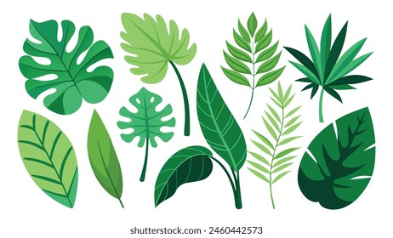
Autumn 1 
Year 1.2

Plants
- I can identify what plants need to stay healthy (water, light, suitable temperature, air, soil)
- I can describe how certain plants survive (examples of sunflower and evergreens)
- I can identify the basic structure of common flowering plants (shown using a labelled diagram)
- I can describe what each of the main parts of a flowering plant does.
- I can compare the structures of at least two variety of common flowering plants. (Marigold plant and an apple tree)
- LEGACY – I know who Mary Seacole was and how she used plants in her work in the past.

Golden Scientific Threads
- Enquiry – What scientific questions have we asked & answered?
- Observation – How have we observed science in practice?
- Evidence – What evidence have we researched or found out from our own experiments?

Autumn 2
Year 1.2
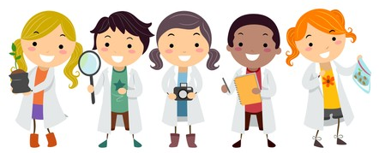
Working Scientifically
- I can ask simple questions and find different ways to answer them.
- I can use simple equipment to make observations.
- I can perform simple tests.
- I can explain what a variable is.
- I can use scientific language to talk about my observations and ideas.
- I can gather and record data, showing this in a bar chart.
- LEGACY – Who was Stephen Hawkings and what was his most famous work?

Golden Scientific Threads
- Enquiry – What scientific questions have we asked & answered?
- Observation – How have we observed science in practice?
- Evidence – What evidence have we researched or found out from our own experiments?

Spring 1
Year 1.2
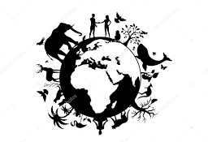
Animals (Including humans)
- I know what an organism is & the difference between living and non-living things.
- I can name and label at least seven different parts of the human body.
- I can name the five senses and identify the part of the human body it is linked with.
- I can identify offspring for a variety of organisms (human baby, lamb, chick, tadpole, hatchling)
- I can describe how an offspring grows into a full growing animal (life cycle of a bee, tadpole and a human)
- I can describe why it is important for humans to exercise, eat healthily and have good hygiene.
- LEGACY – I know who Linda Buck is and what she discovered about our sense of smell.

Golden Scientific Threads
- Enquiry – What scientific questions have we asked & answered?
- Observation – How have we observed science in practice?
- Evidence – What evidence have we researched or found out from our own experiments?

Spring 2
Year 1.2
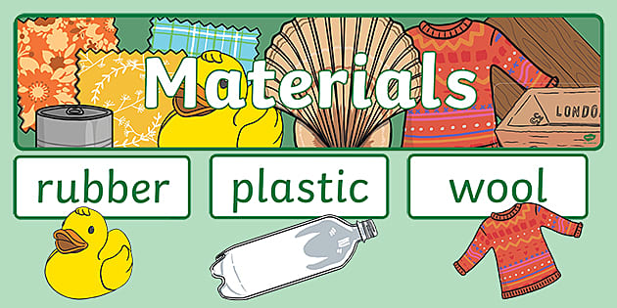
Everyday Materials
- I can group a variety of materials based on their properties (transparent/opaque, melt easily or not melt easily).
- I can compare at least two everyday materials based on their properties (wool, metal, cotton, plastic).
- I can explain at least three different uses for everyday materials (uses for wool, metal, glass).
- I can describe which everyday material is more appropriate for a particular use. (knife: plastic, metal or wood shopping: plastic, paper, fabric)
- LEGACY: I know what the Fair Trade symbol is, what it means and where Fair Trade cotton comes from.

Golden Scientific Threads
- Enquiry – What scientific questions have we asked & answered?
- Observation – How have we observed science in practice?
- Evidence – What evidence have we researched or found out from our own experiments?

Summer 1
Year 1.2
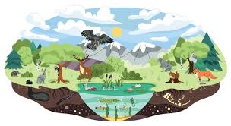
Habitats
- I can identify and describe at least three habitats (river, rainforest, seashore) and at least two microhabitats (rock pool and rotten or old log).
- I can identify at least three plants and/or animals within a specific habitat and also within a specific microhabitat.
- I can identify two different sources of food for specific animals (plants and other animals).
- I can describe how animals obtain their food from plants and other animals by creating a simple food chain with three connections.
- LEGACY – I know who Jacques Piccard was and what habitat he explored.

Golden Scientific Threads
- Enquiry – What scientific questions have we asked & answered?
- Observation – How have we observed science in practice?
- Evidence – What evidence have we researched or found out from our own experiments?

Summer 2
Year 1.2
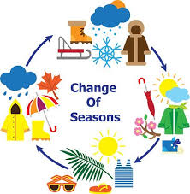
Seasonal Changes
- I can describe how winter affects living things (hibernation, plant growth)
- I can describe how animals’ behaviour changes throughout the four seasons. (autumn: collect food, winter: hibernate, spring migrate and summer: hunting).
- I can describe how plants change through the four seasons. (simple cyclic diagram of a evergreen tree and a deciduous tree).
- I can describe at least four changes within the environment that occur within the seasons. (at least one change from each season).
- LEGACY – I know who Vice-Admiral Robert FitzRoy was and what he started.

Golden Scientific Threads
- Enquiry – What scientific questions have we asked & answered?
- Observation – How have we observed science in practice?
- Evidence – What evidence have we researched or found out from our own experiments?

