Low Level Concerns Policy and Guidance

Spring 2022

Reviewed by WTCS Federation | M. Glenton 09.03.22 | Governing Body

Contents

1. Introduction
2. Summary
3. Keeping Children Safe in Education September 2021
4. Clarity around Allegation vs Low-Level Concern vs Appropriate Conduct
5. Storing and use of Low-Level Concerns and follow-up information
6. Process to follow when a Low-Level Concern is raised
7. Low Level Concern Form

1. Introduction

At The West Tyne Church Schools Federation, we aim to create an open and transparent culture where all concerns about all adults involved with our school are dealt with promptly and appropriately. We aim to identify any concerning, problematic or inappropriate behaviour early; minimise the risk of abuse; and ensure that adults working in or on behalf of our school are clear about professional boundaries and act within these boundaries, and in accordance with our school ethos.
This policy should be read alongside our Safeguarding and Child Protection and Behaviour Policies.

2. Summary

It may be possible that a member of staff acts in a way that does not cause risk to children, but is however inappropriate. A member of staff who has a concern about another member of staff, volunteer, contractor or who, on reflection, recognises that their actions could have been viewed as a risk should inform the Head Teacher about their concern using a Low-Level Record of Concern Form. In the Head Teacher’s absence, the Assistant Head should be contacted instead. If both Head and Assistant Head can not be contacted then a phone call should be placed to the Head Teacher.

3. Keeping Children Safe in Education September 2021

The following is taken from Keeping Children Safe in Education September 2021 and identifies what may be considered behaviour relating to low level concern:

What is a low level concern (LLC)?
409. The term ‘low-level’ concern does not mean that it is insignificant, it means that the behaviour towards a child does not meet the threshold set out at paragraph 338 (in the red box below). A low-level concern is any concern – no matter how small, and even if no more than causing a sense of unease or a ‘nagging doubt’ - that an adult working in or on behalf of the school or college may have acted in a way that:

- is inconsistent with the staff code of conduct, including inappropriate conduct outside of work; and
- does not meet the allegations threshold or is otherwise not considered serious enough to consider a referral to the LADO. (Local Authority Designated Officer)

410. Examples of such behaviour could include, but are not limited to:
- being over friendly with children;
- having favourites;
- taking photographs of children on their mobile phone;
- engaging with a child on a one-to-one basis in a secluded area or behind a closed door; or,
- using inappropriate sexualised, intimidating or offensive language.

411. Such behaviour can exist on a wide spectrum, from the inadvertent or thoughtless, or behaviour that may look to be inappropriate, but might not be in specific circumstances, through to that which is ultimately intended to enable abuse.
412. It is crucial that any such concerns, including those which do not meet the harm threshold (see Part Four - Section one), are shared responsibly and with the right person, and recorded and dealt with appropriately. Ensuring they are dealt with effectively should also protect those working in or on behalf of schools and colleges from potential false allegations or misunderstandings.

4. Clarity around Allegation vs Low-Level Concern vs Appropriate Conduct
Allegation:
Any adult linked to our school who has:
- behaved in a way that has harmed a child, or may have harmed a child and/or;
- possibly committed a criminal offence against or related to a child and/or;
- behaved towards a child or children in a way that indicates he or she may pose a risk of harm to children; and/or
- behaved or may have behaved in a way that indicates they may not be suitable to work with children.

Appropriate:
- Behaviour which is entirely consistent with our school’s Code of Conduct, and the Law.
Low Level Concern:
Any adult linked to our school who has behaved in a way that:
- is inconsistent with the staff code of conduct, including inappropriate conduct outside of work; and
- does not meet the allegations threshold or is otherwise not considered serious enough to consider a referral to the LADO.

5. Storing and use of Low-Level Concerns and follow-up information

Low Level Concern forms and follow-up information will be stored securely within the schools safeguarding systems, with access only by the leadership team. This will be stored in accordance with the school’s GDPR and data protection policies.
The staff member(s) reporting the concern must keep the information confidential and not share the concern with others apart from the Head Teacher or those aware in the senior leadership team.

Low-Level Concerns will not be referred to in references unless they have been formalised into more significant concerns resulting in disciplinary or misconduct procedures.

Whenever staff leave The West Tyne Church Schools Federation, any record of low-level concerns which are stored about them will be reviewed as to whether or not that information needs to be kept or passed on to another establishment.

Consideration will be given to:
(a) whether some or all of the information contained within any record may have any reasonably likely value in terms of any potential historic employment or abuse claim so as to justify keeping it, in line with normal safeguarding records practice; or
(b) if, on balance, any record is not considered to have any reasonably likely value, still less actionable concern, and ought to be deleted accordingly.
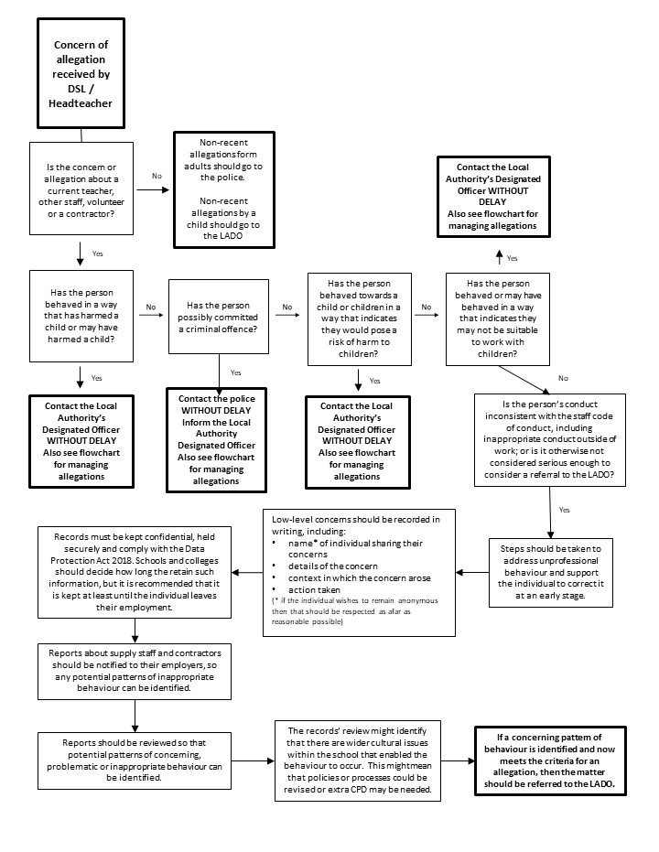
6. Process to follow when a Low-Level Concern is raised
*NB – if the concern is about the Headteacher, then the Chair of Governors should be informed.

Low level Concerns Reporting Form
Your details
Name

Role

Date and time of completing this form
Details of individual whom the concern is about
Name

Role

Relationship to the individual reporting eg manager, colleague
Details of concern
Please include as much detail as possible. Think about the following:
- What behaviour and/or incident are you reporting?
- What exactly happened?
- Why does the behaviour and/or incident worry you?
- Why do you believe the behaviour and/or incident is not consistent with our Staff Code of Conduct?

Details of any children or young people involved
Name(s)

Next Steps
Are you willing to meet with the  headteacher and DSL to discuss your concern? Please circle as appropriate. | Yes | No
Please state any other information that you feel is relevant to the processing
of this concern.
Signature

For use by HT/safeguarding team upon receipt of the concern
Date and time concern received
Signature

Role

Actions to be taken and follow-up.

Flow chart for referrals (Taken from Safeguarding policy)
N
A staff member identifies a concern or potential concern. Is the pupil at immediate risk of harm?

The staff member follows the guidelines for reporting through CPOMS. If the staff is still concerned, Is the DSL or the deputy DSL available to discuss the concern with?
The staff member immediately notifies the DSL either face-to-face or by telephone. Police action may be required.
The staff member follows the guidelines for reporting through CPOMS. DSL considers next steps which could be referral, discussion with parents or further investigation.
The staff member discusses the concern with the DSL. Taking into account observations and using professional judgement, is a referral required?
The DSL makes a referral to children’s social care, keeping the staff member who raised the concern up-to-date with what action is taken.
The pupil continues to be monitored and early help is provided where necessary. If the concern escalates, a referral is made to children’s social care.
Within one working day, a social worker from children’s social care will make a decision about the type of response that is required and will notify the referrer. Where this information is not forthcoming, the referrer should contact the appointed social worker to follow up the referral.
The steps outlined in the next flowchart are then followed.
N
N
Y
Y
Y

