Autumn 1 
Year 3.4
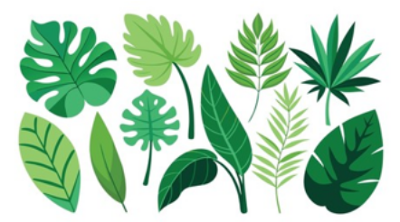
Plants

Year 3 – Foundational Knowledge
- Plant Parts: I can identify and name the main parts of a flowering plant, including the roots, stem, leaves and flowers.
- Plant Requirements: I can identify what plants need to live and grow, including air, light, water, nutrients and space.
- Water Transport: I can observe how water moves through a plant using simple investigations.
- Flowers and Life Cycles: I can identify the role flowers play in the life cycle of a flowering plant.
- Legacy: I know who Alan Titchmarsh is and can describe how he has helped the environment.
Golden Scientific Threads
- Enquiry – What scientific questions have we asked & answered?
- Observation – How have we observed science in practice?
- Evidence – What evidence have we researched or found out from our own experiments?

Autumn 1
Year 3.4
Plants

Year 4 – Developing Knowledge
- Plant Parts: I can explain the functions of the different parts of a flowering plant and how they work together.
- Plant Requirements: I can compare what different plants need to survive and grow and explain why their requirements may vary.
- Water Transport: I can investigate and explain how water is transported through a plant.
- Flowers and Life Cycles: I can explain the role of flowers in pollination, seed formation and seed dispersal.
- Legacy: I can explain how Alan Titchmarsh has influenced people's understanding of gardening and the environment.
Golden Scientific Threads
- Enquiry – What scientific questions have we asked & answered?
- Observation – How have we observed science in practice?
- Evidence – What evidence have we researched or found out from our own experiments?

Autumn 2
Year 3.4
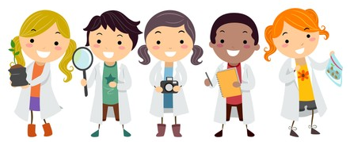
Working Scientifically
Year 3 – Foundational skills
- Scientific Questions: I can ask simple questions about things I observe.
- Investigations: I can take part in a simple practical investigation.
- Recording Findings: I can record what I find using drawings, labels, simple tables or charts.
- Conclusions: I can describe what I have found out from an investigation.
- Evidence: I can use what I have observed as evidence to help answer a question.

Golden Scientific Threads
- Enquiry – What scientific questions have we asked & answered?
- Observation – How have we observed science in practice?
- Evidence – What evidence have we researched or found out from our own experiments?

Autumn 2
Year 3.4
Working Scientifically
Year 4 – Developing skills
- Scientific Questions: I can ask relevant scientific questions and suggest ways to investigate them.
- Investigations: I can plan and carry out simple practical, comparative and fair tests.
- Recording Findings: I can record results using appropriate scientific language, labelled diagrams, tables and charts.
- Conclusions: I can use my results to make a conclusion and suggest how an investigation could be improved.
- Evidence: I can use evidence from my investigation to support an answer and raise further questions.

Golden Scientific Threads
- Enquiry – What scientific questions have we asked & answered?
- Observation – How have we observed science in practice?
- Evidence – What evidence have we researched or found out from our own experiments?

Spring 1
Year 3.4
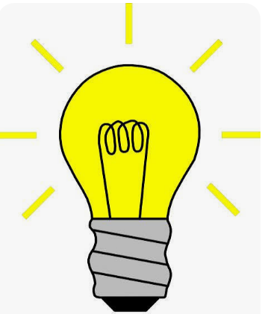
Light

Year 3 – foundational skills
- Seeing Objects: I can explain that we need light to see objects and that dark is the absence of light.
- Sun Safety: I can explain why I should never look directly at the Sun and identify ways to protect my eyes.
- Materials: I can identify materials as transparent, translucent or opaque.
- Shadows: I can explain how shadows are made and investigate shadows using a light source.
- Light and Shadows: I can observe what happens to a shadow when the light source or object is moved.
- Legacy: I know who James Clerk Maxwell was and can identify his connection to light.
Golden Scientific Threads
- Enquiry – What scientific questions have we asked & answered?
- Observation – How have we observed science in practice?
- Evidence – What evidence have we researched or found out from our own experiments?

Spring 1
Year 3.4
Light

Year 4 – Developing skills
- Seeing Objects: I can explain how light allows us to see objects and describe what happens when there is no light.
- Sun Safety: I can explain the dangers of looking directly at the Sun and describe appropriate safety precautions.
- Materials: I can compare transparent, translucent and opaque materials and explain how they affect light.
- Shadows: I can investigate how the position and size of a shadow changes when the position of the light source or object changes.
- Light and Shadows: I can explain why changing the distance or position of a light source changes the size and shape of a shadow.
- Legacy: I can explain the importance of James Clerk Maxwell's work and its connection to our understanding of light.
Golden Scientific Threads
- Enquiry – What scientific questions have we asked & answered?
- Observation – How have we observed science in practice?
- Evidence – What evidence have we researched or found out from our own experiments?

Spring 2
Year 3.4
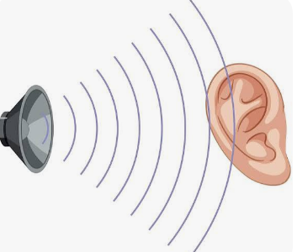
Sound

Year 3 – Foundational skills
- Sound Sources: I can identify different sources of sound and state that sounds are produced by vibrations.
- Vibrations: I can recognise that vibrations from sounds travel through a medium to the ear.
- Pitch: I can find patterns between the pitch of a sound and features of the object producing it.
- Volume: I can find patterns between the volume of a sound and the strength of the vibrations producing it.
- Distance: I can recognise that sounds become fainter as the distance from the sound source increases.
- Legacy: I know who Marin Mersenne was and can explain what he found out about sound.

Golden Scientific Threads
- Enquiry – What scientific questions have we asked & answered?
- Observation – How have we observed science in practice?
- Evidence – What evidence have we researched or found out from our own experiments?

Spring 2
Year 3.4
Sound

Year 4 – Developing skills
- Sound Sources: I can explain that sound is produced when an object vibrates and describe how these vibrations produce sound.
- Vibrations: I can explain how vibrations travel through a medium to reach the ear.
- Pitch: I can investigate and explain patterns between pitch and the length, tightness or thickness of the object producing the sound.
- Volume: I can investigate and explain how the strength of vibrations affects the volume of a sound.
- Distance: I can explain why sounds become fainter as the distance from the sound source increases.
- Legacy: I can explain how Marin Mersenne's investigations contributed to our understanding of sound.

Golden Scientific Threads
- Enquiry – What scientific questions have we asked & answered?
- Observation – How have we observed science in practice?
- Evidence – What evidence have we researched or found out from our own experiments?

Summer 1
Year 3.4

Animals including humans
- Skeletons and Muscles: I can give examples of animals, including humans, that have skeletons and muscles for support, protection and movement.
- Bones: I can identify important bones within the human body that protect us.
- Digestive System: I can describe the simple functions of the basic parts of the human digestive system.
- Teeth: I can identify different types of teeth in humans, including canines, incisors, pre-molars and molars.
- Functions of Teeth: I can explain the function of at least two different types of human teeth.
- Legacy: I know who Pierre Fauchard was and can explain how his discoveries have shaped the future.

Golden Scientific Threads
- Enquiry – What scientific questions have we asked & answered?
- Observation – How have we observed science in practice?
- Evidence – What evidence have we researched or found out from our own experiments?

Summer 1
Year 3.4
Animals including humans
- Skeletons and Muscles: I can explain how skeletons and muscles work together to provide support, protection and movement in humans and other animals.
- Bones: I can identify and explain the functions of important bones that protect different parts of the human body.
- Digestive System: I can explain the functions of the different parts of the human digestive system and how they work together.
- Teeth: I can compare the different types of human teeth and explain how their shapes are suited to their functions.
- Functions of Teeth: I can explain the different functions of incisors, canines, pre-molars and molars and relate these to eating and digestion.
- Legacy: I can explain how Pierre Fauchard's discoveries influenced the development of modern dentistry.
Golden Scientific Threads
- Enquiry – What scientific questions have we asked & answered?
- Observation – How have we observed science in practice?
- Evidence – What evidence have we researched or found out from our own experiments?

Summer 2
Year 3.4
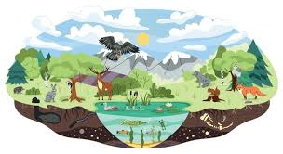
Living things and their habitats

- Grouping Living Things: I can group living things in a variety of ways, including animals, flowering plants, non-flowering plants, vertebrates and invertebrates.
- Classification: I can explore and use a classification key to help identify living things in my local area.
- Changing Environments: I can explain and give examples of how environments can change because of human and natural impacts.
- Protecting Habitats: I can suggest ways to help protect habitats and find out about conservation projects in my local area.
- Legacy: I know who Carl Linnaeus was and can explain how his discoveries help us identify different organisms.

Golden Scientific Threads
- Enquiry – What scientific questions have we asked & answered?
- Observation – How have we observed science in practice?
- Evidence – What evidence have we researched or found out from our own experiments?

Summer 2
Year 3.4
Living things and their habitats

- Grouping Living Things: I can classify living things into groups using their similarities and differences and explain the reasons for my classifications.
- Classification: I can independently use and interpret a classification key to identify a range of living things.
- Changing Environments: I can compare the positive and negative effects of human and natural changes on different environments.
- Protecting Habitats: I can research conservation projects and evaluate different ways of protecting habitats and the organisms that live within them.
- Legacy: I can explain how Carl Linnaeus developed systems for classifying organisms and evaluate how his work continues to influence the identification of living things today.

Golden Scientific Threads
- Enquiry – What scientific questions have we asked & answered?
- Observation – How have we observed science in practice?
- Evidence – What evidence have we researched or found out from our own experiments?

