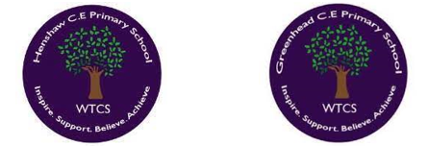
LONG TERM PLAN
MATHS
Reception
 | Autumn | Spring | Summer
Number | - To use number names and mathematical language in the context of play and conversation.  - To recognise numerals up to 10  - To count sets of objects to at least 5 with correct 1-1 correspondence.  - To explore the composition of numbers to 5 and begin to develop some automatic recall of these number facts.  - To subitise amounts within 5. | - To recognise and write numerals up to 10.  - To explore the composition of numbers to 10 and begin to develop some automatic recall of these number facts  - To use manipulatives to explore the composition of numbers to 6 and then 10  - To use part whole models to represent the composition of numbers to 10  - To begin to combine groups in the course of play. | - Count objects, actions & sounds beyond 10  - Count quantities beyond 10 (Development Matters)  - Order numbers to 10  - Recall some number bonds to 10  - Link numerals to value  - Have a deep understanding of number to 10, including the composition of each number. (Early Learning Goal)  - Subitise (recognise quantities without counting) up to 5 (Early Learning Goal)  - Automatically recall (without reference to rhymes, counting or other aids) number bonds up to 5 (including subtraction facts) and some number bonds to 10, including double facts. (Early Learning Goal)
Numerical Pattern | - Verbally count to at least 10.  - To say the number one more or one less than a number within 5. | - To say number names in order to at least 20  - To order numerals to 10 | - Verbally count beyond 20, recognising the pattern of the counting system  - Compare quantities up to 10 in different contexts, recognising when one quantity is greater than, less than or the same as the other quantity.  - Explore and represent patterns within numbers up to 10, including evens and odds, double facts and how quantities can be distributed equally.  - Say one more /one less than numbers to at least 10  - Recognise and make equal groups
Shape, Space and Measure | - Select, rotate and manipulate shapes to develop spatial reasoning skills. (Development Matters)  - To notice how shapes can fit together to make other shapes.  - To name common 2d shapes (circle, square, rectangle, triangle) | - To name common 3D shapes in the course of building (Cylinder, Cube, Cuboid, Cone)  - To use everyday language to sequence events in a day. (First, Then, Next)  - To choose criteria (‘rules’) to sort objects into sets.  - To replicate a simple 3D structure. | - Know that shapes can have more shapes within them. (Development Matters)  - Name some common 3d shapes and recognise these in the environment. (Cylinder, Cube, Cuboid, Cone)  - Develop awareness of the passage of time (Yesterday, today, tomorrow)  - Compare length, weight and capacity. “This is heavier than that.” “Which container holds more?” (Development Matters)
* No ELG specifically related to Shape, Space and Measure in the new EYFS framework 2021. The Mathematics Educational Programme states, “to develop their spatial reasoning skills across all areas of mathematics including shape, space and measures.”

Year 1

Year 2

How we cater for mixed-aged Mathematics in our Key Stage 2 classes
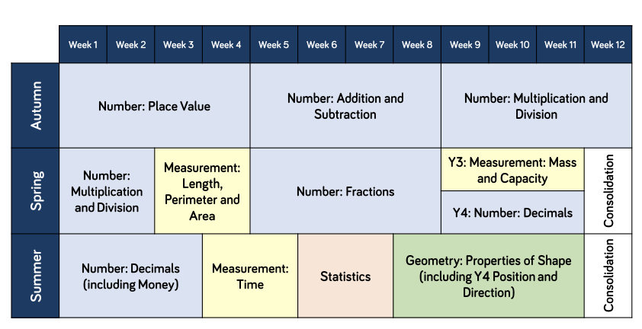
Year 3/4

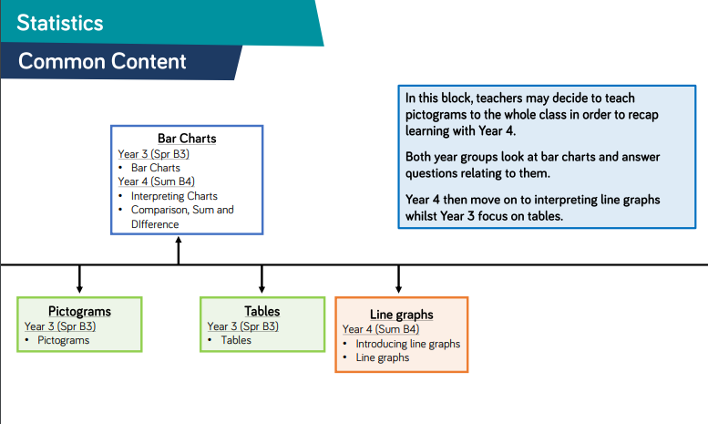

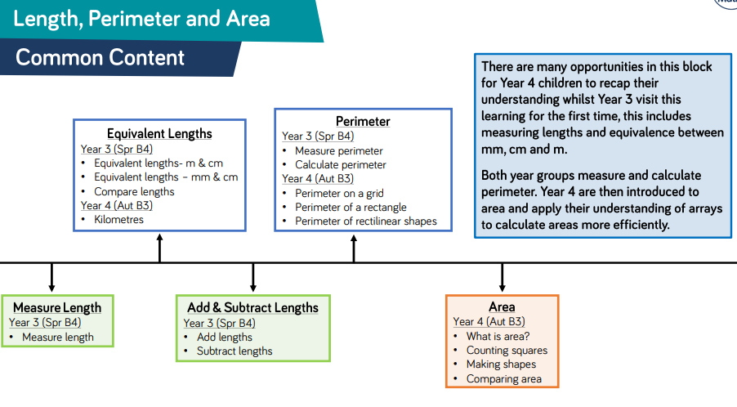
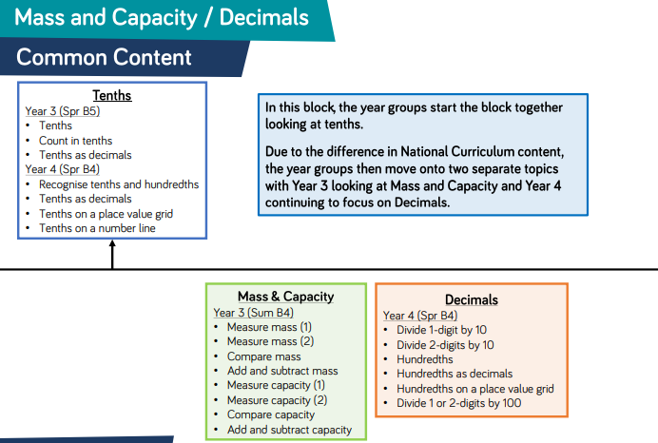

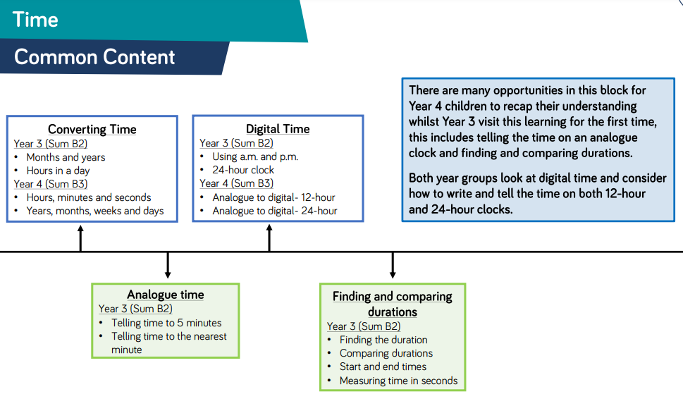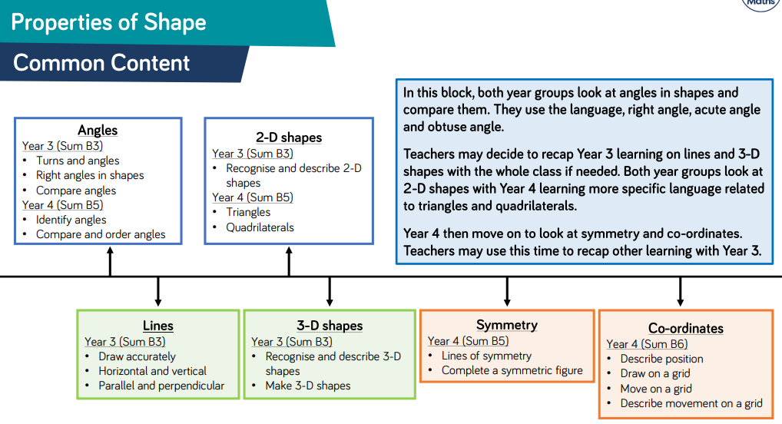

How we cater for mixed-aged Mathematics in our Key Stage 2 classes
Year 5/6