RE in UKS2 Cycle A
God: What does it mean of God is holy and loving?
- I can identify some different types of biblical texts, (a psalm or prayer/ song, religious experience and a letter) using technical terms accurately.
- I can explain connections between biblical texts and Christian ideas of God, using theological terms.
- I can show how Christians put their beliefs into practice in worship.
- I can explain how biblical ideas and teachings about God as holy and loving might make a difference in the world today, developing insights of my own.
Incarnation: Was Jesus the Messiah?
- I can explain the place of incarnation and Messiah within the ‘big story’ of the Bible.
- I can identify Gospel and Prophecy texts, using technical terms.
- I can explain connections between biblical texts, Incarnation and Messiah, using theological terms.
- I can show how Christians put their beliefs about Jesus’ Incarnation into practice in different ways in celebrating Christmas.
- I can suggest how the ideas that Jesus is the Messiah makes sense in the wider story of the Bible.
Gospel: What would Jesus do?
- I can identify features of Gospel texts (teachings, parable and narrative).
- I can compare my ideas about Gospel texts with ways in which Christians interpret biblical texts.
- I can make clear connections between Gospel texts, Jesus’ ‘good news’, and how Christians live in the Christian community and in their individual lives (forgiveness project, projects to help the homeless.)
- I can relate biblical ideas, teachings or beliefs (about peace, forgiveness, healing) to the issues, problems and opportunities of my own lives and the life of my own community in the world today.
Salvation: What did Jesus do to save Human beings?
- I can explain how Incarnation and Salvation fit on the timeline of the ‘big story’ of the Bible.
- I can suggest meanings for narratives of Jesus’ death/ resurrection, comparing their ideas with ways in which Christians interpret these texts.
- I can make clear connections between the Christian belief in Jesus’ death as a sacrifice and how Christians celebrate Holy Communion/Lord’s Supper.
- I can describe the value and impact of ideas of sacrifice in their own lives and the world today.
Islam: What does it mean for Muslims to follow God?
- I can identify and explain Muslim beliefs about God, the Prophet and the Holy Qur’an.
- I can describe and explain ways in which Muslim sources of authority guide Muslim living (Qur’an guidance on Five Pillars; hajj practices follow example of the Prophet).
- I can make clear connections between Muslim beliefs and worship (Five Pillars, mosques, art).
- I can give evidence and examples to show how Muslims put their beliefs into practice in different ways of living.
Thematic: Why is pilgrimage important to some religious believers?
- I can identify some of the beliefs that lie behind places and times of pilgrimage in at least two religions
- I can explain ways in which stories that lie behind sites of pilgrimage connect with beliefs (Israel as G-d’s Chosen or Favoured People in Judaism)
- I can compare the similarities and differences between ways in which people undertake pilgrimage and how they affect the way they live.
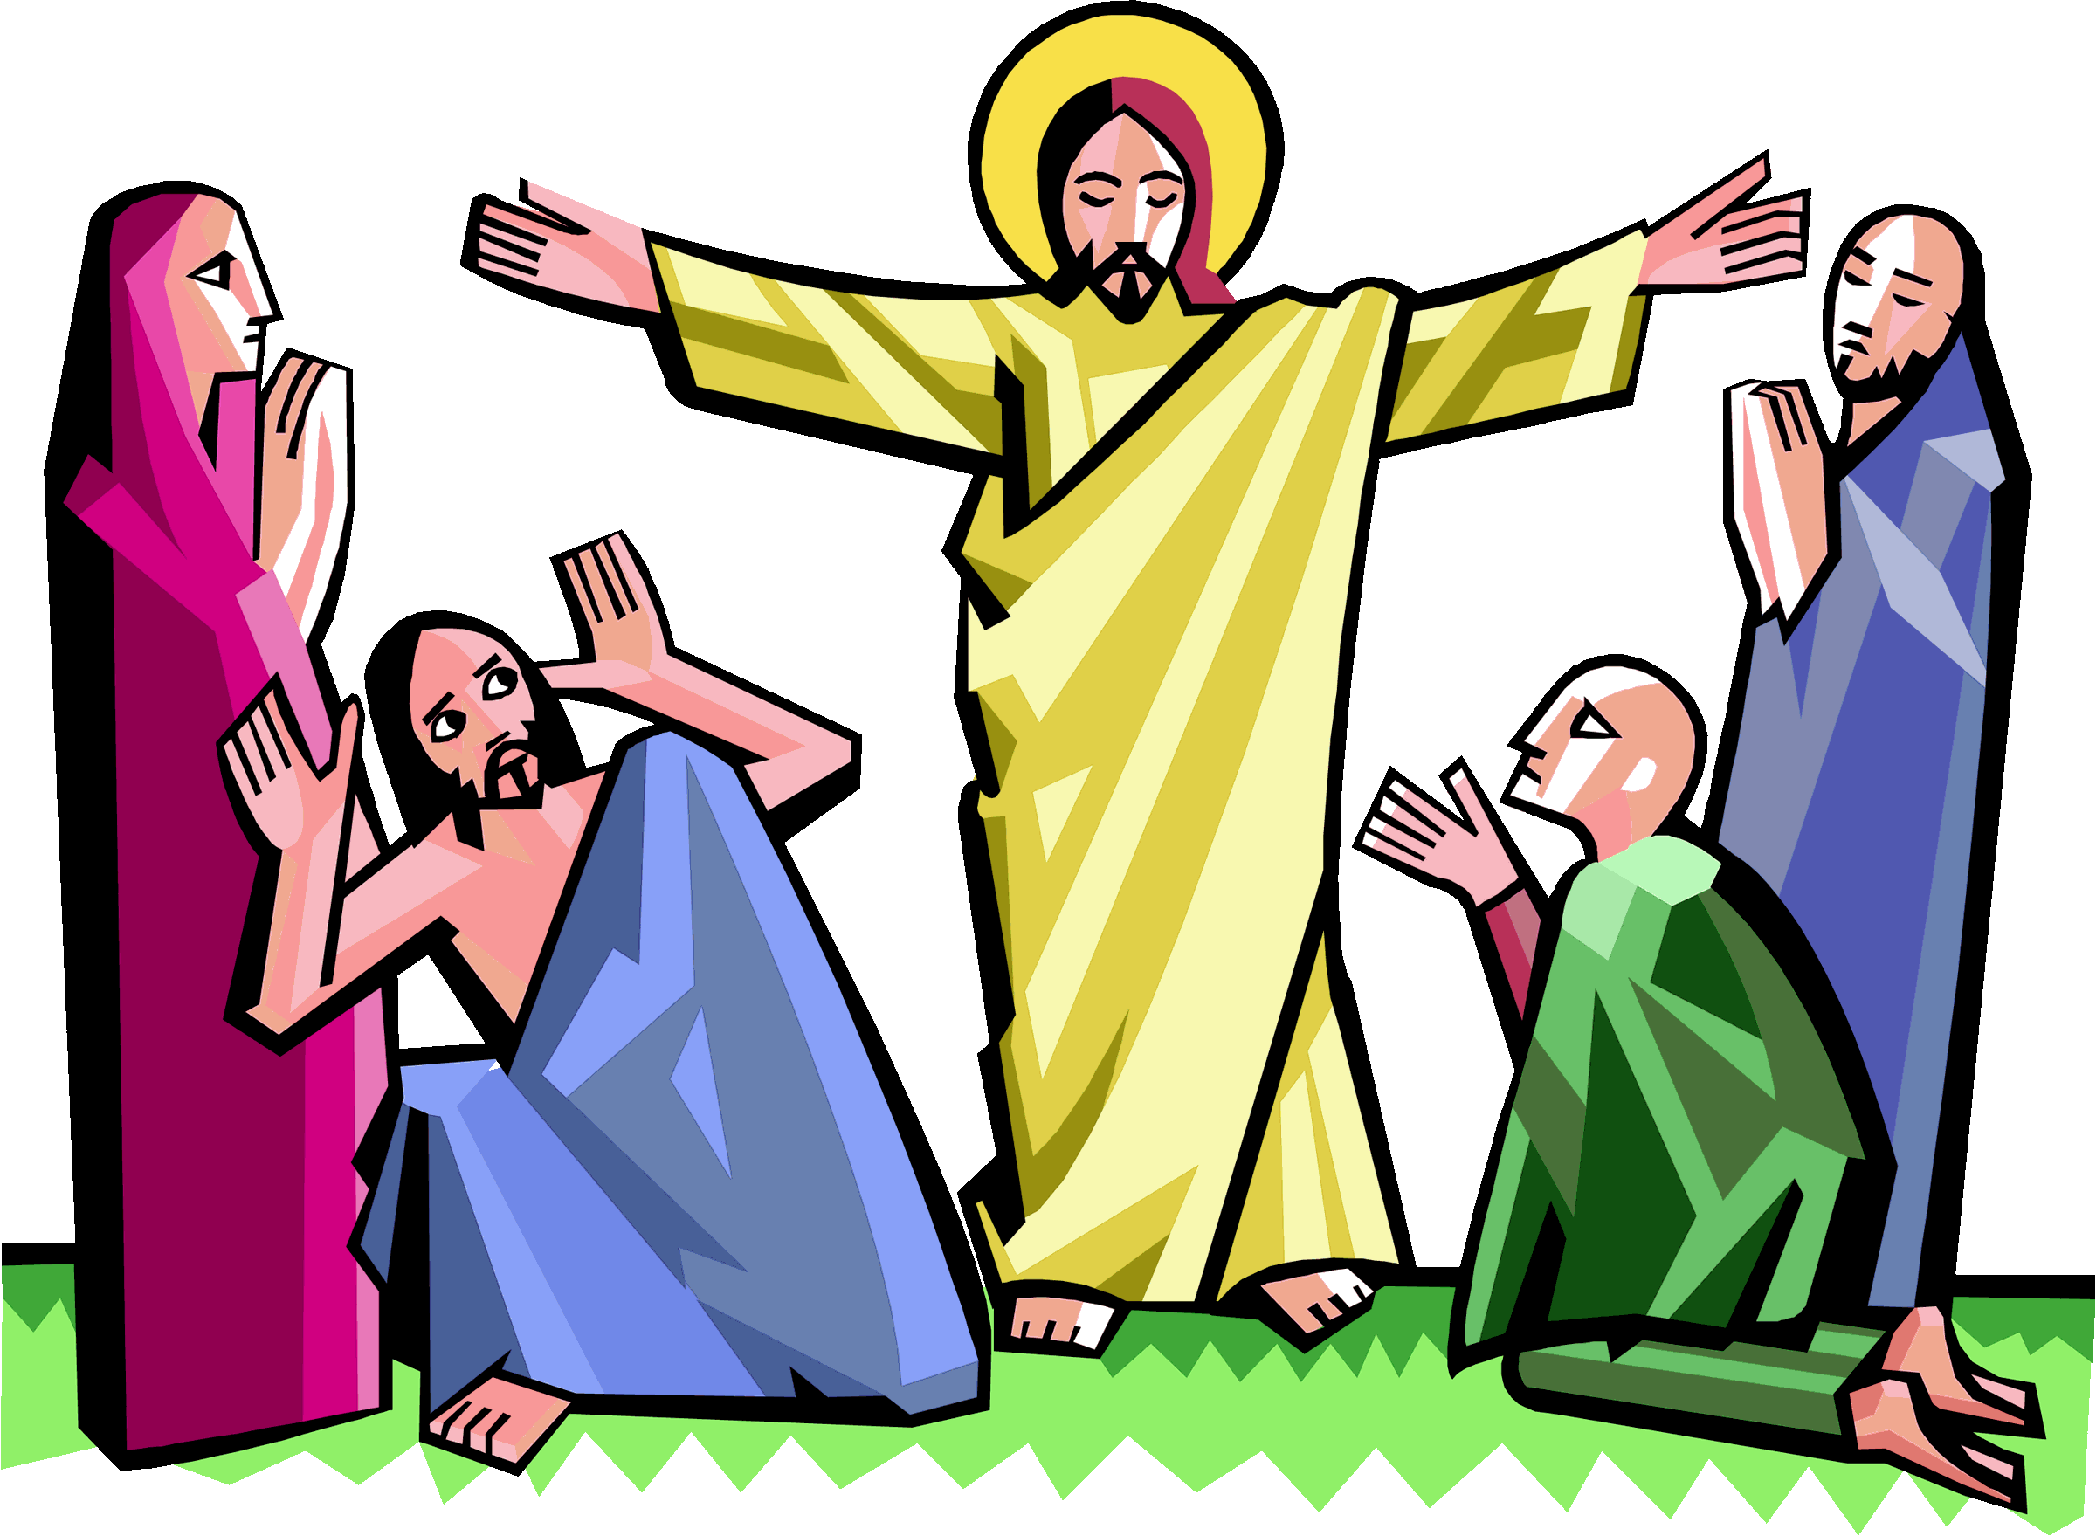
- I can evaluate and explain the importance of pilgrimage in the world today, giving good reasons for my views.

