Maths in Year 3
- Count in multiples of 4, 8, 50 and 100
- Compare and order numbers up to 1000
- Add and subtract numbers mentally, including round numbers to HTU
- Subtract numbers mentally, including round numbers to HTU
- Add and subtract using standard column method
- Subtract using standard column method
- Estimate answers to calculations and use the inverse to check answers
- Know 3×, 4× and 8× tables
- Count up and down in tenths
- Show that tenths are objects or quantities divided into ten equal parts
- Compare and order simple fractions
- Recognise and show equivalent fractions
- Find and write fractions of a set of objects
- Add and subtract fractions with common denominators (less than one)
- Measure, compare and calculate measures using standard units
- Measure the perimeter of simple 2-D shapes
- Add and subtract money, including giving change
- Tell and write the time from an analogue clock, incl. using Roman numerals
- Estimate and read time to the nearest minute
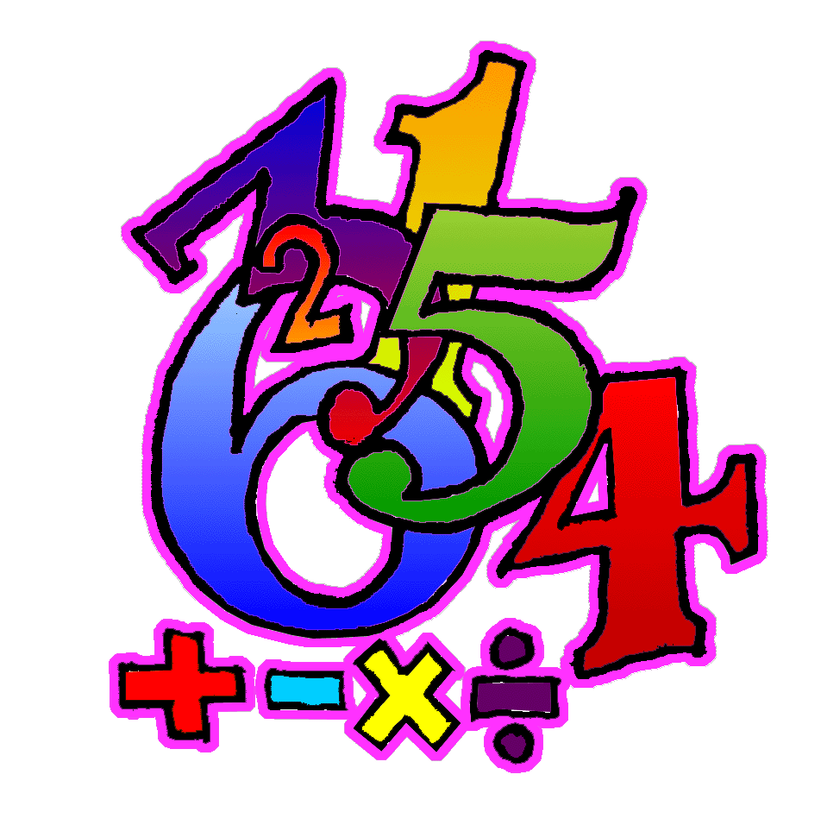
- Identify horizontal, vertical, parallel and perpendicular lines
- Identify whether angles are greater or less than a right angle
- Interpret and present data using bar charts, pictograms and tables

