English  Our class texts are books by William Shakespeare – our significant author.  Our guided reading text is ‘The River Queen’ by Saviour Poretta.  Our writing styles for this half-term are:  - Newspaper reports  - Non-chronological reports  - Stories from other cultures  - Sonnets and narrative poems |  | R.E.  Our thematic learning in R.E. this half-term poses the question: What would Jesus do?  We will be identifying:  - the features of the Gospel text.  - the meanings of Gospel texts studied and comparing the ideas with ways in which Christians interpret biblical texts.  - the similar features between the Gospel text, Jesus and how Christians live in the Christian community and in their individual lives. |  |  | Maths  In Maths during this half-term, our objectives will focus on properties of shape and statistics:  We will be learning to:  - identify multiples and factors.  - solve problems involving multiplication and division.  - Use the formal written method for multiplication and division.  - Read and write units of measure and convert between them.  - Solve problems with ratio.  - Use simple formulae. |  |  | Geography  In Geography, we are finding out about Polar Regions and climate change.  We will be learning about:  How the main Polar Regions are different  - How polar oceans differ to other oceans  - What is climate change and how does it affect polar regions  - Natural resources found in the Arctic  - Indigenous people  - Tourism in Antarctica
PSHE/RSE  This half term is all about ‘Changes’.  We will be looking at:  - looking after ourselves  - how we change as we grow up  - becoming independent  - taking more responsibility  - managing our feelings |  |  | Mississippi  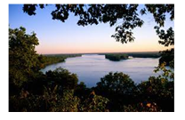  Curriculum Grid  Spring 1 Y5/6 |  |  | Science  In Science this half-term, we will be finding out about electricity.  We will be learning to:  - Identify components of a circuit.  - Understand how to test circuits by changing components.  - Recognise how to test voltages and electric currents using a range of resources.  - Research and produce a report asking, ‘How do cells produce electricity?’. |  |  |  | 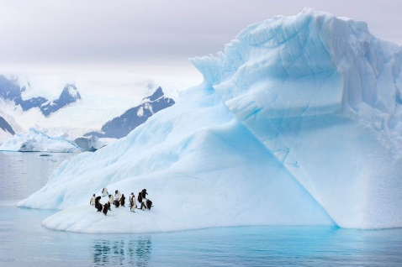  Comparing the Artic to Anartica.
French  In French, this half-term, we will be learning about Au Cafe.  This will include:  - Ordering food from a French menu  - Asking for the bill  - Saying hello, goodbye, please and thankyou in French | DT  In DT, this half-term, we are going to be looking at electrical circuits.  This unit will involve researching, designing and making a light sensor. |  |  | Music  In Music, we will be receiving Ukulele lessons.  We will also be taking part in whole school singing lessons. This will include, sing in unison with others. |  |  | Computing  In computing, we are going to be focusing on flat file databases. This will involve:  - Understanding what a field and a record is in a database.  - How to group information using a database.  - How to use and create charts to compare data. |  | P.E.  In P.E. this half-term, we will be continuing our swimming lessons at the Wentworth Leisure Centre on a Monday. We will also be focussing on striking and fielding in our NUFC lessons.  Children will need to come in their P.E. kits on Tuesday each week.

Links to our curriculum drivers Mississippi Class Spring 1 Y5.6
The following drivers underpin our school curriculum and, with our vision and values, allow us to deliver our curriculum strategy. These key drivers are personal to our schools and reflect the locational, social and educational needs of our community.
Curriculum Driver | Links within our curriculum this half term
Christianity and Faith | - PSHCE – Being different – different faiths/beliefs/cultures.  - Being involved with and listening to RE leaders.  - Father Steve worship assemblies.
Our Local Area | - Comparing the weather in the UK to that of Antarctica and the Arctic.  - Rivers workshop with Northumbria Water.  - Year 6 study project linked with Durham University.
Outdoor Growing, Learning and Environment | - Science – what is electricity, how it is used and where it comes from.  - Eco Schools Representatives.
Wider World and Diversity | - PSHCE/RE – how we change and how we are all different.  - Being involved with and listening to School Council.  - Young leaders Award, learning about how we can improve the world around us.  - Studying a different language – French.  - Geography – climate change and its effect on the world.  - Computing – networking/online safety/cyberbullying.  - Computing – how data is stored in a database and can be accessed around the world.

